THE EFFECT OF ASPERGILLUS FUMIGATUS AND CANDIDA ALBICANS ON THE DENDRITIC CELLS AND THE ROLE OF BETA GLUCAN IN THIS EFFECT

Isil Fidan, Ayse Kalkanci, Emine Yesilyurt, Berna Erdal
Gazi University Faculty of Medicine, Department of Medical Microbiology, Ankara, TURKEY

Running title: Effect of fungi on the dendritic cells

*Corresponding author:
Address:
Isil Fidan, MD

Gazi University, Faculty of Medicine, Department of Medical Microbiology
Dekanlik Binasi 2.Kat
Beşevler/ANKARA 06500, TURKEY
Phone: +90 312 2024626
Fax: +90 312 4358632
e-mail: isilfidan@yahoo.com

Sponsorships: This study was supported by the Gazi University Research Fund (no: 01/2008-07), Ankara, TURKEY.

SUMMARY
Dendritic cells (DCs) are able to initiate and regulate the immune response to fungal infections. β-glucan stimulates immune system, modulating cellular and humoral immunity. It has beneficial effect in fighting fungal infections. We investigated the effect of C.albicans and A.fumigatus infection on human DCs. DCs stimulated by C.albicans and A.fumigatus induced DC maturation by increasing CD80 and CD 86 costimulatory molecules. DCs stimulated by fungi produced IL-8 and IL-12p70. Whereas IL-10 production from stimulated DCs did not differ from uninfected DCs. Also, the addition of β-glucan to the DCs stimulated by fungi promoted the activation and maturation of DCs. In conclusion, our results suggested that DCs are capable of initiating the innate and adaptive immune response against fungal infections. In addition, β-glucan can be used as a novel stimulator to the DC-based vaccination against fungal infections.

Key words: Dendritic cells- fungal infection- β-glucan

INTRODUCTION
Dendritic cells (DCs) are the antigen presenting cells that reside in the peripheral regions such as skin, nose mucosa, respiratory system and digestive system and in all tissues except from brain, testis and eyes and they play key roles in the initiation of adaptive immunity. These cells, recognized as professional antigen presenting cells, induce the immune response by stimulating the undifferentiated T cells (Faivre et al. 2007). When activated, dendritic cells mature and migrate to regional lymph nodes in order to activate antigen specific T cells (Sallusto and Lanzavecchia 1994). Moreover, DCs play an effective role in the interaction between innate and adaptive immunity (Gafa et al. 2007). DCs also exist in nonlymphoid tissues consisting of antigen entrance sites such as skin while they are widespread in lymphoid tissues (Sundquist et al. 2004).
DCs express great amounts of CD11c and MHC class II molecules. During their migration, DCs have some phenotypic and functional changes. When they mature, MHC molecules, costimulatory molecules such as CD86, CD80 and CD40 are activated. These molecules are essential for the activation of T cell. During maturation, Th cells (T-helper cells) are differentiated as Th1 and and Th2 according to the cytokine type secreted. IL-12 secreted from DCs causes Th1 differentiation and it is important in developing immune response against bacterial infections. At the same time, IL-10 secreted from DCs causes Th2 differentiation and this carries some importance for the immune response against extracellular parasites (Flohe et al. 2006).
DCs are the immune cells that have been the focus of many studies recently. There have been some findings that many pathogens attempt to affect the host immune response by interacting with DC functions (Millington et al. 2006). They have crucial roles in infections, host-microbe interactions and the balance between protective immunity and immunopathology (Perruccio et al. 2004).
The opportunistic fungal infections such as Candida albicans (C.albicans) and Aspergillus fumigatus (A.fumigatus) cause some life threatening infections especially during the immunosuppressive conditions such as AIDS or organ transplantations and they have an increasing incidence. Some different host defense mechanisms play effective roles during infections against fungi. Innate immune response is basically effective during the early stages of the infection (Perruccio et al. 2004).
DCs have important roles in the initiation of cellular response against fungi. It has been discovered that DCs have direct effects both in vitro and in vivo anti-fungal immunity. DCs phagocytose both yeast and hyphal forms of the fungus (Perruccio et al. 2004). Phagocytosis of A. fumigatus conidia by DCs leads to the secretion of some cytokines. So, it is considered that DCs initiate the adaptive immune responses to Aspergillus species and directly influence the outcome of an Aspergillus infection (Gafa et al. 2007, Brakhage et al., 2010).
The changes occurring in dendritic cell structures and functions because of fungal infections play important roles in the development of anti-fungal immunity (Gafa et al. 2007). Therefore, the use of therapeutic approaches in fungal infections targeting DCs carry a great importance in the prevention of the agents that cause mortality especially in immunosuppressive patients and the treatment of these infections.
β-glucan (beta-glucan), a polysaccharides, is a component of cell wall structure in various microorganisms such as pathogen bacteria and fungus. β-glucan is one of the strongest immune system stimulator known so far and plays an effective role in the protection against several infection agents. β-glucan has some strong effects in the immunotheraphy of some diseases such as cancer. Recently, β-glucan has been accepted as an important pharmacological agent in human beings since its several immunomodulatory effects such as anti-cytotoxic, anti-mutagenic and anti-tumorigenic effects have been identified (Lull et al. 2005).
In our study, we aimed to identify the changes in the structure and function of DCs due to some fungi and the effect of β-glucan administered externally on those changes.

MATERIALS AND METHODS
Isolation of human Peripheral blood mononuclear cells (PBMC)- Heparinized blood was collected from healthy human donors. PBMCs were separated from blood by Ficoll-hypaque density gradient centrifugation (Sigma, UK). After centrifugation, buffy coats were collected and washed in Phosphate Buffered Saline (PBS, Gibco, Germany) three times and resuspended at a concentration of 2x10⁶ cells/ml in complete RPMI 1640 medium containing 2mM L-glutamine, 100 U/ml penicillin, 100 μg/ml streptomycin, 0.05 mM 2ME and supplemented with 10% fetal calf serum (Gibco, Germany). Cell viability was 95% by the trypan blue exclusion test. PBMCs were allowed to adhere to 6-well plates. After 2 hours at 37°C the nonadherent cells were removed and the adherent cells were separated by incubated with Mg²⁺ and Ca²⁺ free PBS containing 0.5 mM EDTA at 37°C (Sallusto and Lanzavecchia 1994).

Preparation of dendritic cell culture- Cell culture medium (Complet RPMI) was RPMI-1640 (Sigma, Germany) supplemented with Penicillin (100 U/ml, Biochrom AG, Germany), Streptomycin (100 μg/ml, Biochrom AG, Germany), L-glutamin (2 mM, Biochrom AG, Germany), 2-mercaptoethanol (50 μM, Fluka Switzerland), and 10% heat-inactivated FCS (Biochrom AG, Germany). At day 0 cells were seeded at 2×10⁶ per 100 mm dish in 10 ml complet RPMI containing 50 ng/ml rhGM-CSF (Biosource, USA) and 1.000 U/ml IL-4. Culture medium was replaced partially every 3 days and fresh cytokine (rmGM-CSF and IL-4) were added. For complete maturation on the day 10 non-adherent cells were collected by gentle pipetting, centrifuged at 300×g for 5 min at RT, and resuspended with 10 ml fresh complete RPMI in 100 mm tissue culture plastic dish containing 100 U/ml rmGM-CSF and lipopolysaccharide (LPS, Sigma, Germany) at 1 μg/ml. Cells were then cultured for 1 or 2 more days. Cultured cells were washed once and an aliquot volume mixed 1:1 in Trypan Blue solution (Sigma, Germany). DCs were counted as viable under the microscope in a Neubauer chamber and the number was adjusted to 5 × 10⁶ cells/ml.
Cell separation and flow cytometry- CD11c⁺ DCs were purified by magnetic cell sorting (MACS) by using positive selection according to the manufacturer's protocol (Miltenyi, USA). Briefly, the cells were incubated with magnetic microbeads conjugated with monoclonal anti-human CD11c antibodies in MACS buffer for 15 min at 4°C. After this, the cells were run through a MACS column (Miltenyi) in a magnetic field. The column was then removed from the magnet, and the positive cells were flushed out. Then CD11c⁺ DCs were analysed further by flow cytometer (Coulter, USA).

Introduction of fungi and DCs- One ml of BM-DCs (10⁶) were delivered in per well. One ml of A.fumigatus (10⁶ conidia/ml) and C. albicans (10⁶ yeast/ml) were added to the wells, respectively. So, DCs were stimulated by fungi. Amphotericin B was used to prevent fungal overgrowth in wells. Control culture flasks did not contain fungi. They only contained medium and DCs. Each samples was studied in triplicates. Control culture plates and culture plates containing fungi were added β-glucan (Immunex). All plates were incubated for 24 h in 5% CO₂ at 37 ^{ο}C. At the end of time period, contents of culture plates were transferred into tubes and centrifuged. The culture supernatants were removed and stored at -70°C until used in ELISA.

Flow Cytometric Analysis of PBMCs- The pelleted cells were washed in PBS and stained with antibodies for 30 minutes at 4^{ο}C. DCs (2x10⁶ cells/ml) were incubated with monoclonal antibodies specific for human CD antigens. Antibodies used were anti-CD80, and anti-CD68 (e-bioscience, USA). IgG1-FITC/IgG2-PE were used as isotypic control. Flow cytometric analysis were done by using a Coulter FC500 flow cytometer (Coulter, USA).

Cytokine secretion- Levels of cytokines such as IL-8 (İnterleukin-8), IL-10, IL-12p70 were determined by specific Enzyme-linked immunosorbent assay (ELISA) techniques according to the manifacturer’s instructions (Biosource, USA). The concentration of cytokines was determined spectrophotometrically. The absorbance was read at 450 nm (BioTek, USA). We constructed a standard curve using cytokine standards. The cytokine concentrations for unknown samples were calculated according to the standard curve.
Statistical methods- The results were analysed using the one-way analysis of variance (ANOVA). The Bonferroni test was used as Post Hoc analysis. p<0.05 was considered to be significant.

RESULTS
Analysis of DCs- Analysis of cells by flow cytometry on a plot of CD11c versus side scatter showed that more than 94 % of the purified cells expressed CD11c⁺ (Fig.1).
DCs maturation- In the analysis of the effectiveness of C.albicans and A.fumigatus on DC maturation, it was found out that the expression of DC costimulatory molecules such as CD80 and CD86 remarkably increased after the stimulation of DCs with both of the fungi. In addition, the expression of these costimulatory molecules increased in the wells containing DCs infected by fungi with the addition of β-glucan after fungal infection; however, this increase was not significantly different from the increase in the wells infected by fungus without β-glucan (p>0.05).
The increase in the expression of these costimulatory molecules after the addition of β-glucan to the DCs stimulated by fungus shows that DCs have effective antigen-presenting cell function after the fungal infection and in the presence of β-glucan.

The levels of cytokines- In our study we observed that the IL-8 and IL-12p70 cytokine levels increased in DCs stimulated by C.albicans and A.fumigatus compared to the wells without any infection. However, these increases were not statistically significant (p>0.05). The stimulation of DCs with fungus did not lead to any significant changes in IL-10 levels compared to the wells with only DCs. Nevertheless, the addition of β-glucan to DCs stimulated with fungus caused statistically significant changes in the levels of IL-8, IL-10 and IL-12p70 (p<0.05).
The changes observed in the IL-8 cytokine levels after 24, 48 and 72 hours are shown in Table I. According to the table, the IL-8 cytokine levels after 24, 48 and 72 hours in DCs stimulated with fungus increased compared to the wells with only DCs, but the changes were not statistically significant (p= 0.291, 0.445, 1, respectively ). The addition of β-glucan to the DCs stimulated with C.albicans led to statistically significant changes after 24, 48 and 72 hours (p<0.05) (Table I).
The changes observed in IL-10 cytokine levels in the wells containing DCs stimulated by C.albicans after 24, 48 and 72 hours are shown in Table II. The stimulation of DCs by fungus did not lead to significant changes in IL-10 secretion after 24, 48 and 72 hours in the wells containing only DCs (p=1). While the addition of β-glucan to DCs stimulated by C.albicans did not cause any statistically significant increases in IL-10 levels after 24 and 48 hours compared to the wells without β-glucan, there was a statistically significant increase in IL-10 levels after 72 hours (p<0.05) (Table II).
The changes in the IL-12p70 cytokine levels in the wells containing DCs stimulated with C.albicans after 24, 48 and 72 hours are shown in Table III. When DCs was stimulated with fungus, there was an increase in the secretion of IL-12p70 compared to the wells containing DCs non-stimulated by fungus. However, the changes after 24, 48 and 72 hours were not found statistically significant (p= 0.292, 0.089, 0.477, respectively). Still, the addition of β-glucan to DCs stimulated with C.albicans led to statistically significant changes after 24, 48 and 72 hours (p<0.05) (Table III).
The same result was obtained when DCs stimulated by A. fumigatus (data not shown).

DISCUSSION
DCs, the professional antigen presenting cells, play important roles in the initiation of cellular response against the foreign antigens. They are also effective to provide innate defense against microbial antigens (Gervassi et al. 2004). DCs are activated by different microorganisms or their products (Aiba and Tagami 1999). Having been activated when the infecting agent recognizes by DC, DCs play some roles in the activation and control of the adaptive immunity through the cytokines they secrete (Granucci et al. 2002).
DCs are also important in the defense against fungal infections. DCs are effective against the C.albicans infections as antigen presenting cells. They also phagocytose both yeast and hyphal forms of the fungus. It has been found out that DCs not only phagocytose, process and present fungal to T cells, but also kill fungi as efficiently as macrophages do (Netea et al. 2004). DCs also have an important role in the initiation of the cellular immune response against fungi. Fungi and its products cause a strong activation stimulus in DCs, leading to DC maturation with upregulation of costimulatory molecules and production of cytokine leading to different T cell responses. DCs are important for the further treatment approaches since they are effective in enhancing anti-fungal immune response (Buentke and Scheynius 2003). Perruccio et al reported that the adoptive transfer of DCs activate Th cells and effect the outcome of fungal infections in hematopoietic stem cell transplantation (Perruccio et al. 2004).
In our study aimed to determine DC activation signals and the release of cytokines such as IL-8, IL-10 and IL-12p70 following DCs stimulated with A. fumigatus and C. albicans strains, we observed some changes in the cell surface costimulatory molecules and DC functions after DCs were infected by fungi such as A. fumigatus and C. albicans. Furthermore, the presence of β-glucan affected the activation of DCs infected by fungi.
There have been a lot of studies focusing on the immunomodulatory effects of β-glucan. However, there have been a few dealing with the effects of β-glucan on the maturation and activation of DCs after fungal infections. For this reason, we aimed to determine the effects of β-glucan administration on DCs during fungal infections.
The DC maturation process is one of the important phases in the initiation of adaptive immune response. The maturation signals for DCs may derive from various sources. This process is regulated by extracellular stimulators such as microbial products or membrane associated ligands. DC maturation occurs due to the changes in morphological, phenotypical and functional features of DCs. DC activation is characterized by cytokine secretion and the expression of certain surface markers. These are essential for DCs to stimulate effective T cell response. DCs affect immune response by increasing costimulatory molecule expression. CD80 and CD86 are the costimulatory molecules crucial for both T cell response and Th differentiation.
In our study, DCs stimulated by A. fumigatus and C. albicans led to DC maturation. DC maturation is characterized by the increase in the expression of costimulatory molecules on dentritic cell surface and by the secretion of cytokines such as IL-12 that provide strong stimulators for T cell development and differentiation (Lin et al. 2006). Our study showed that costimulatory molecules (CD80 and CD86) and proinflammatory cytokines (IL-8, IL-12p70) increased after DC was infected by A. fumigatus and C. albicans.
The increase in the expression of these costimulatory molecules and cytokine secretion in the DCs stimulated by A. fumigatus and C. albicans indicate the importance of DC activation during such fungal infections. However, the infection of DCs by fungus did not cause a remarkable change in IL-10 levels, an antiinflammatory cytokine eliciting Th2 type response, compared to the DCs non-stimulated by fungus. The insignificant change in IL-10 levels after fungal infections may be explained by the fact that Th1 cell-mediated response plays an effective role in the protection against fungal infections (Romagnoll et al. 2004).
Romagnoll et al. have reported that different forms of C. albicans enhance DC maturation and stimulate Th 1 type response (Romagnoll et al. 2004).
Gafa et al have also reported that in vitro stimulation of DC by A. fumigatus increases the surface expression of CD11b and CD18 activation signals and they have added that DC plays an important role in the regulation of innate and adaptive immune response against A. fumigatus by enabling the production of various chemokines (Gafa et al. 2007).
Netea et al have indicated that although DC stimulated by C. albicans produced a great amount of TNF-α and IL-8, TNF and IL-8 release by DC was only 5–10% of that released by monocytes or macrophages (Netea et al. 2004).
IL-12 is a cytokine that plays an important role in the interaction between innate and adaptive immunity. The expression of IL-12 is one of the most specific markers for DCs functionally activated (Kikuchi et al. 2002). IL-12 stimulates natural killer cells and T cells to secrete cytokines and to initiate lytic activity. Moreover, IL-12p70 directs the immune system towards Th1 response (Gafa et al. 2006). DCs stimulated by C.albicans and A.fumigatus play important roles in the Th1 cell differentiation by generating IL-12 secretion. Clinical and experimental studies have shown that Th1 cell reactivity plays an important role in the control of fungal infections such as invasive aspergillosis (Gafa et al. 2007)
β-glucan has several immunopharmacological effects such as IL-6, TNF and nitrogen oxide secretion from macrophages, the adjuvant effect in the antibody production and antitumor effect (Akramiene et al. 2007). Since it enhances DC maturation, it can be used in DC-based vaccination and in the combination therapies to boost DC maturation (Kikuchi et al. 2002).
In our study, the addition of β-glucan, an important immunomodulator, to DCs stimulated by fungus caused an increase in the expression of costimulatory molecules and also in the proinflammatory and antiinflammatory cytokine response.
Depending on the results of our study that IL-8 and IL-12p70 secretion increased after the stimulation by fungus and there was even a further increase with the addition of β-glucan, we may conclude that these cytokines may play some roles in the fungal infections and the immunomodulatory effects associated with β-glucan. The increase in IL-8 and IL-12p70 cytokines in DCs stimulated by fungus indicates the importance of Th1 response during fungal infections. Moreover, the infection of DCs by fungus did not lead to significant changes in the secretion of IL-10, which is the indicator of Th2 response, emphasizes again the importance of Th1 response during fungal infections.
Avasti et al have reported that after in vitro infection of bone-marrow derived DC of mice with dimorphic fungi such as Coccidioides posadasii lead to significant increase in the levels of IL-12. They also suggest that the differences in the activation status of DC in mice may be responsible for the discrepancy in their susceptibility to C. posadasii (Awasthi and Magee. 2004).
The findings derived from our study show that β-glucan has strong effects on DC maturation and activation during fungal infections. It is considered that by enabling DC maturation and activation, β-glucan activates cytokine response and so, it is considered to effect the regulation of immune response (Carmona et. 2007) Kikuchi et al have also reported that Candida β-glucan may augment DC maturation (Kikuchi et al. 2002).
Consequently, DC based therapeutic approaches have already been considered to be important in the prevention of fungal infections. As is observed in our study, the changes in the maturation and activation of DC during fungal infections become more remarkable in the presence of β-glucan and so this agent may significantly enhances DC maturation and activation. The effect of β-glucan on DC endows it with an important role during the immune response. Since β-glucan is an important alternative for the therapeutic approaches regulating host immune response, DC based immunotherapeutic approaches in the presence of β-glucan for the immunosuppressed patients with fungal infections are expected to be very effective in the future treatments.

REFERENCES

Aiba S, Tagami H 1999. Dendritic cell activation induced by various stimuli, e.g. exposure to microorganisms, their products, cytokines, and simple chemicals as well as adhesion to extracellular matrix. J Dermatol Sci 20: 1-13.
Akramiene D, Kondrotas A, Didziapetriene J, Kevelaitis E 2007. Effects of β-glucans on the immune system. Medicina 43: 597-606.

Awasthi S, Magee DM 2004. Differences in expression of cell surface co-stimulatory molecules, Toll-like receptor genes and secretion of IL-12 by bone marrow-derived dendritic cells from susceptible and resistant Mouse strains in response to Coccidioides posadasii. Cell Immunol 231: 49-55.
Brakhage AA, Bruns S, Thywissen A, Zipfel PF, Behnse J 2010. Interaction of phagocytes with filamentous fungi. Curr Opin Microbiol 13: 409-415.

Buentke E, Scheynius A 2003. Dendritic cells and fungi. APMIS 111: 789-796.

Carmona E, Vassallo R, Vuk-Pavlovic Z, Standing JE, Theodore TJ, Limper AH 2007. Pneumocystis cell wall β-Glucans induce dendtitic cell costimulatory molecule expression and inflammatoryactivation through a Fas-Fas ligand mechanism. J Immunol 177: 459-467.
Faivre V, Lukaszewicz AC, Alves A, Charron D, Payen D, Haziot A 2007. Accelerated in vitro differentiation of blood monocytes into dendritic cells in human sepsis. Clin Exp Immunol 147: 426-439.
Flohe SB, Agrawal H, Schmitz D, Gertz M, Flohe S, Schade FU 2006. Dendritic cells during polymicrobial sepsis rapidly mature but fail to initiate a protective Th1-type immune response. J Leuko Biol 79: 473-481.
Gafa V, Lande R, Gagliardi MC, Severa M, Giacomii E, Remoli ME, Nisini R, Ramoni C, Di Francesco P, Aldebert D, Grillot R, Coccia EM 2006. Human dendritic cells following Aspergillus fumigatus infection Express the CCR7 receptor and a differential pattern of interleukin-12 (IL-12), IL-23, and IL-27 cytokines, which lead to a Th1 response. Infect Immun 74: 148-1489.
Gafa V, Remoli MR, Giacomini E, Gagliardi MC, Lande R, Severa M, Grillot R, Coccia EM 2007. In vitro infection of human dendritic cells by Aspergillus fumigatus conidia triggers the secretion of chemokines for neutrophil and Th1 lymphocyte recruitment. Microb Infect 9: 971-980.

Gervassi A, Alderson MR, Suchland R, Maisonneuve JF, Grabstein KH, Probst P 2004. Differential Regulation of Inflammatory Cytokine Secretion by Human Dendritic Cells upon Chlamydia trachomatis Infection. Infect Immun 72: 7231-9.

Granucci F, Andrews DM, Degli-Esposti MA, Ricciardi-Castagnoli P 2002. IL-2 mediates adjuvant effect of dendritic cells. Trends Immunol 23: 169-171.

Kikuchi T, Ohno N, Ohno T 2002. Maturation of dendritic cells induced by Candida β-D-glucan. Int Immunopharma 2: 1503-1508.
Lin YL, Lee SS, Hou SM, Chiang BL 2006. Polysaccharide purified from Ganoderna lucidum induces gene expression changes in human dendritic cells and promotes T Helper 1 immune response in BALB/c mice. Mol Pharmacol 70: 637-644.

Lull C, Wichers HJ, Savelkoul FJ 2005. Antiinflammatory and immunomodulating properties of fungal metabolites. Mediators Inflamm 2: 63-80.
Millington OR, Di Lorenzo C, Phillips RS, Garside P, Brewer JM 2006. Suppression of adaptive immunity to heterologous antigens during Plasmodium infection through hemozoin-induced failure of dendritic cell function. J Biol 5: 5.1-5.22.

Netea MG, Gijzen K, Coolen N, Verschueren I, Figdor C, Van der Meer JWM, Torensma R., Kullberg BJ 2004. Human dendritic cells are less potent at killing Candida albicans than both monocytes and macrophages. Microb Infect 6: 985-989.
Perruccio K, Boza S, Montagnoli C, Bellocchio S, Aversa F, Martelli M, Bistoni F, Velardi A, Romani L 2004. Prospects for dendritic cell vaccination against fungal infections in hematopoetic transplantation. Blood Cells Mol Dis 33: 248-255.
Romagnoll G, Nisini R, Chlani P, Marlotti S, Teloni R, Cassone A, Torosantucci A 2004. The interaction of human dendritic cells with yeast and germ-tube forms of Candida albicans leads to efficient fungal processing, dendritic cell maturation, and acquisition of a Th1 response-promoting function. J Leukol Biol 75: 117-126.
Sallusto F, Lanzavecchia A 1994. Efficient presentation of soluble antigen by cultured human dendritic cells is maintained by granulocyte/Macrophage colony-stimulating factor plus interleukin 4 and downregulated by tumor necrosis factor α. J Exp Med 179: 1109-1118.
Sundquist M, Rydström A, Wick MJ 2004. Immunity to salmonella from a dendritic point of view. Cell Microbiol 6: 1-11.

Fig. 1. Flow cytometric analysis of CD11c (+) DCs

Fig. 2. The expression of CD86 of DCs ( A. Dendritic cell, B. Dendritic cell infected with C.albicans )

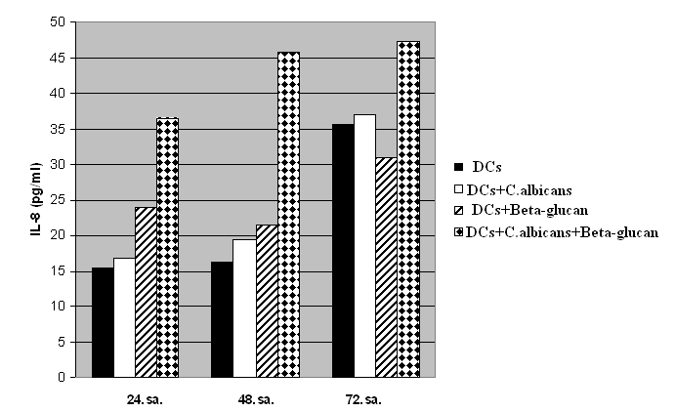
Table I. IL-8 cytokine levels in dentritic cells.

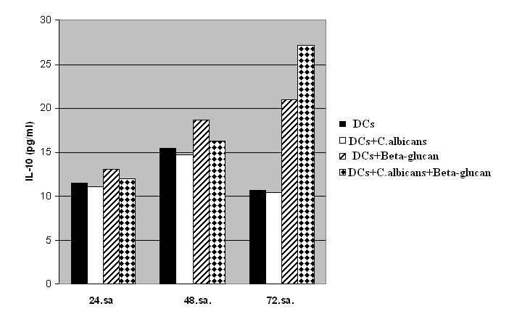
Table II. IL-10 cytokine levels in dentritic cells.

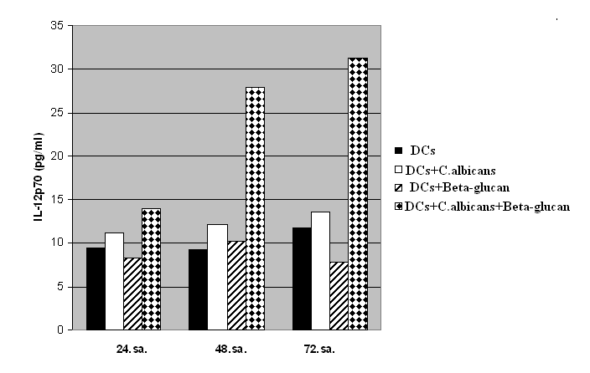
Table III. IL-12p70 cytokine levels in dendritic cells

Fig. 1. Flow cytometric analysis of CD11c (+) DCs

Fig. 2. The expression of CD86 of DCs ( A. Dendritic cell, B. Dendritic cell infected with C.albicans )

