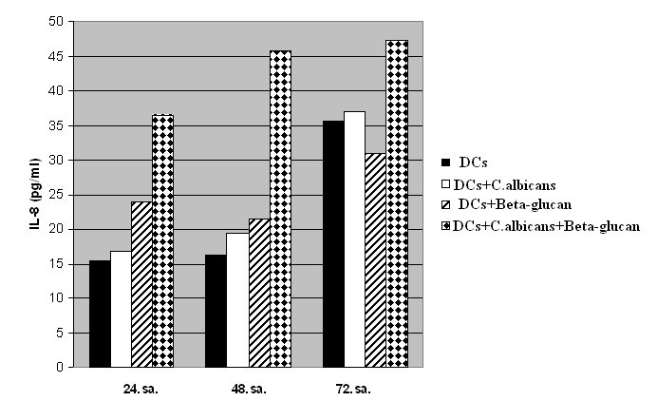

**Table I.** IL-8 cytokine levels in dentritic cells.

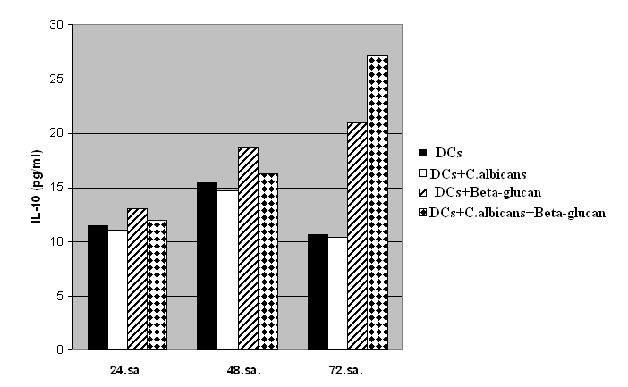

**Table II.** IL-10 cytokine levels in dentritic cells.

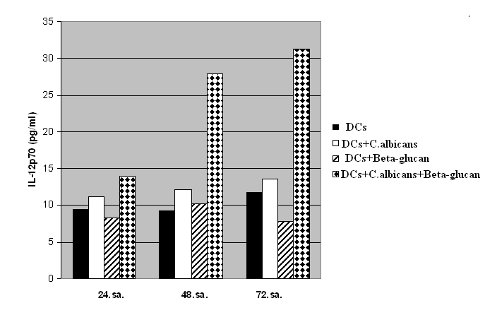

**Table III.** IL-12p70 cytokine levels in dendritic cells