Identification of Biochemical and Molecular Markers in Tomato Yellow Leaf Curl Virus Resistant Tomato Species
Corresponding author* E-mail: Sherinmahfouze@yahoo.com
ABSTRACT
Tomato yellow leaf curl virus (TYLCV) is devastating to tomato (Solanum lycopersicum) crops and resistant cultivars are highly effective in controlling the disease. Breeding programmes aimed at producing TYLCV-resistant tomato cultivars have utilized resistance sources derived from wild tomato species. So far, all reported breeding programmes have introgressed TYLCV resistance from a single wild tomato source. Here, we tested degree of resistant different nine tomato species to TYLCV. Results showed that S. chilense, S. peruvianum, S. hirsutum and S. minutum appeared resistant to TYLCV. On the other hand, the maximum PPO and POD isozyme activities were recorded in the susceptible plants of S. penneleii, while the minimum in the resistant plants of S. minutum. RAPD-PCR using five primers revealed the differences between the TYLCV resistant wild tomato species and the healthy control. Thus, the TYLCV resistant S. hirsutum revealed the highest number with 14 unique markers, followed by S. cheesmaniae with 11 markers, while S. chilense and S. peruvianum revealed six markers. These polymorphic fragments are valuable for future use in tomato breeding programs. This information is also deemed important for the contribution to the expanding database used for marker assisted selection in tomato breeding. By knowing the reliable primers to use and thus obtaining definitive results, we can further test lines of tomatoes with confidence and improve the selection process.
Key words: Symptoms, peroxidase, polyphenol oxidase, RAPD-PCR.
Introduction
Tomato production worldwide is under the constant threat of geminiviruses (genus Begomovirus, family Geminiviridae) transmitted by the whitefly Bemisia tabaci. Some begomoviruses infecting tomato, such as Tomato yellow leaf curl virus (TYLCV) have a single DNA-A like genomic component (monopartite) (Navot et al. 1991). TYLCV is a major constraint for open field tomato production in many regions of the world. The disease is induced by a number of begomovirus species and strains, among them, TYLCV, widely spread worldwide (Moriones and Navas-Castillo 2000, Fauquet and Stanley 2005). Management of TYLCV usually consists in spraying large amounts of insecticides to control the population of the whitefly virus vector. Abuse has greatly contributed to the development of pesticide-resistant B. tabaci populations (Palumbo et al. 2001).
Classical breeding for resistance first involves the identification of resistance sources, which are often found in wild germplasm unadapted to agriculture; this is followed by the introgression into cultivars via phenotypic selection of resistant progeny. Sources of resistance to TYLCV have been discovered in wild tomato species, including Solanum pimpinellifolium, S. peruvianum, S. chilense, S. habrochaites and S. cheesmaniae (Ji et al. 2007a). Thus, breeding efforts to develop TYLCV resistance have been largely based on transfer of genes from these wild Solanum species. The type of resistance, the availability of the infected vectors and the presence of different viruses causing TYLCV make classical selection slow and difficult because phenotypic analyses of partial resistance or tolerance traits are often of limited utility. Marker-assisted breeding overcomes such problems focusing on the direct selection of genomic loci underlying the trait.
This research focused on screening wild tomato lines resistance to tomato yellow leaf curl virus. In addition, identify molecular marker (RAPD-PCR) linked to the resistance loci from these wild tomato accessions that can be used for marker-assisted selection in breeding programs.
Material and Methods
Plant material:
Eight wild Solanum spp used in this study are listed in (Table 1) obtained from (Centre for Genetic Resources, The Netherlands) and one tomato cultivar Alissa.
Virus and whitefly maintenance:
The Egyptian isolate of TYLCV supplied from (Virology laboratory, Faculty of Agriculture, University of Ain shams). TYLCV were maintained in susceptible tomato (cv. Castle Rock) in an insect-proof greenhouse. Whitefly colonies (B. tabaci, biotype B) were reared on cotton plants (Gossypium hirsutum) grown in muslin-covered cages maintained within an insect-proof greenhouse.
TYLCV inoculation:
Adult whiteflies were provided a 48-h acquisition access period on TYLCV-infected tomato source plants, after which they were provided a 48-h inoculation access period (IAP) on tomato test plants (10 plants per species), 17–22 days after sowing. To ensure 100% infection, the plants were inoculated with 50 whiteflies per plant. Control, non-inoculated plants of the same genotypes were exposed to non-viruliferous whiteflies for a 48-h IAP. Following the IAP, whiteflies were discarded by treating plants systemically with imidacloprid. The plants were raised for 3-4 weeks in an insect-proof greenhouse at 26–32ºC prior to transplanting to the field.
Detection of TYLCV by Tissue blot immunoassay (TBIA):
Tissue blots were prepared essentially as described by (Lin et al. 1990). Prints were made from leaf petioles, vascular cores of petioles and bark samples were trimmed to an appropriate size for blotting. A smooth fresh cut was made with a razor blade and the cut surface was pressed gently and evenly to the membrane. After the membrane was imprinted with the tissue samples and dried, it was usually placed in a solution of 1% Bovine Serum Albumin (BSA) and Phosphate Buffer Saline (PBS) and incubated for 1 h at 25ºC to block any remaining protein binding sites. The treated membrane was placed in the virus specific antiserum diluted in PBS 1:500 and then incubated for 1 h at room temperature with gently shacking. The membrane was washed three times with PBS-Tween (PBST) at 5 min interval. The goat anti rabbit immunoglobulin-alkaline phosphate conjugate (Sigma A 4503) dilution 1:1000 in conjugate buffer {PBST + 2% Polyvinylpyrrolidone (PVP) + 0.2% Ovalbumin)} was added to the membrane and incubated for 1 h at room temperature. The membrane was washed three times with PBS-Tween at 5 min interval. The substrate solution (Nitro Blue Tetrazolium and 5-bromo 4-chloro 3-indolyl phosphate) was added and incubated for 5 min at room temperature. After the color appeared, the membrane was rinsed quickly with H₂0 then air-dry.
Polyphenol oxidase (PPO) isozymes extraction:
Native-polyacrylamide gel electrophoresis (Native-PAGE) was conducted to identify isozyme variations among resistant and susceptible tomato plants compared to the control using polyphenol oxidase isozymes according to (Stagemann et al., 1985). 500 mg fresh leaves were homogenized in liquid N₂ and 100 µl of 0.2 M Phosphate buffer was added (pH 7.0 was adjusted by Potassium Phosphate, monobasic) and 10 µl of 2-Mercaptoethanol before centrifugation at 14000 rpm for 15 min at 4°C. The supernatant was stored at a temperature of -20°C until isozyme analysis. Polyphenol oxidase isozymes were detected according to (Baaziz et al. 1994), in which the gel was immersed in a solution containing 0.1% 1-dihydroxyphenyl alanine solubilized in 0.05 M phosphate buffer pH 7.5. Relative band mobility was measured in relation to the dye front and indicated by Rf values.
Peroxidase (POD) isozymes electrophoresis:
Peroxidase isozymes were analyzed using the native polyacrylamide gel electrophoresis (native-PAGE) 10%, according to Vallejos (1983). The gel was run for 2 h at 10ºC and 30 mA in a vertical electrophoresis unit. POD-isozymes were detected by incubating the gels for 5-20 min in a reaction mixture containing 0.5 mM benzidine hydrochloride and 10 mM H₂O₂ in 0.05 M acetate buffer, pH 4.9. Peroxidase isozymes were designated by their migration position (mm of the origin line) on the gel.
DNA extraction:
Young leaves of TYLCV resistant tomato species and the healthy control were collected and soaked in liquid nitrogen for DNA extraction using the 2% CTAB method modified by Agrawal et al. (1992).
Random amplified polymorphism DNA-polymerase chain reaction (RAPD-PCR) analysis:
A total of five primers sequenced in (Table 2) were used to amplify DNA (manufactured by Bioneer, New technology certification from ATS Korea). The total reaction mixture was 15 µl contained 10× PCR buffer, 2 mM MgCl₂, 0.2 mM dNTP mixed, 10 pmol primer, 1.25 U Taq polymerase and about 150 ng genomic DNA. DNA amplification was obtained through 35 cycles in a DNA thermal cycler. The temperature profile was as follow: denature temperature 94°C for 30 sec.; annealing temperature 45°C for 1 min; and extension temperature 72 for 1 min, final extension at 72ºC for 5 min.
Amplification product analysis:
The amplified DNA (15 μl) for all samples was electrophoresed on 1% agarose containing ethedium bromide (0.5 μg/ml) in 1X TBE buffer (89 mM Tris-HCl, 89 mM Boric acid, 2.5 mM EDTA, pH 8.3) at 75 constant volt, and determine with UV transilluminator. The size of each fragment was estimated with reference to a size marker of 10 Kb DNA ladder (BioRoN, Germany).
Gel analysis:
Gels were analyzed by UVI Geltec version 12.4, 1999-2005 (USA).
Results and Discussion
TYLCV symptoms.
Thirty days following inoculation with TYLCV, the tested plants were assayed for TYLCV-induced symptom severity during the growth period. There were fundamental differences both in the onset and the degree of symptom development among the different tomato species. Plants of the susceptible S. pimpinellifolium were the first to produce symptoms, which began with a crinkle, vein clearing and leaf curl, S. glandulos appeared yellowing of the leaves; S. penneleii showed vein banding, curling of young leaves and crinkle, while S. esculentum var Hybrid Alissa F1 exhibited mild mosaic and leaf curl (Table 3). On the contrary, other species such as S. chilense, S. peruvianum, S. hirsutum, S. minutum and S. cheesmaniae were completely symptomless when compared with the non-inoculated control plants (Table 3). The presence of TYLCV in leaves was tested by TBIA (Fig. 1). These results were in an agreement with Bian et al., (2007) who mentioned that plants defense against pathogens involves a range of mechanisms. A well-characterized resistance mechanism known as the gene-for-gene response is governed by specific interactions between the pathogen avirulence (avr) gene and the corresponding resistance (R) gene of the plant (Dangl and Jones 2001). A passive mechanism allowing plants to escape pathogen attack is the lack of a specific host factor required by the virus for its replication or spread (Diaz-Pendon et al. 2004). Polston and Anderson (1997) who found that whitefly-transmitted begomoviruses, such as TYLCV and tomato mottle virus (ToMoV), cause great losses to tomato production in the world. To date, no resistance has been found in the Solanum lycopersicum germplasm although some tomato varieties have been reported to be less susceptible than others during severe epidemics (Laterrot 1993). However, resistance to TYLCV has been found in numerous tomato wild species, including S. pimpinellifolium, S. peruvianum, S. chilense, S. habrochaites, and S. cheesmaniae (Scott et al. 1995; Vidavsky and Czosnek 1998). S. chilense accession LA1969 showed the highest level of resistance among the 23 accessions representing five tomato species based on symptom expression and virus detection criteria (Zakay et al. 1991). However, resistance appears to be controlled by one to five genes depending on the plant source, therefore, several strategies have been used by plant breeders to produce TYLCV-resistant plants incorporating tolerance or resistance gene(s) from the related wild species of tomato into cultivated backgrounds. Resistance to TYLCV in S. chilense is controlled by the major gene Ty-1, which exhibits a reduction of the virus titers and long-distance movement of the virus in the plant (Michelson et al. 1994).
Polyphenol oxidase (PPO) and peroxidse (POD) isoforms:
PPO analysis displayed a total of 12 bands at different Rf values varying from 0.104 to 0.899, whereas 10 bands were polymorphic at 83.33% polymorphism, and the two bands at Rf values (0.644 and 0.711) were monomorphic among the TYLCV resistant, susceptible tomato plants and the healthy control (Fig. 2). On the other hand, POD profiles appeared 13 bands at Rf values ranging from 0.207 to 0.928, thus 11 bands were polymorphic with 84.62% polymorphism, two bands were commonly among the TYLCV resistant, susceptible tomato plants and the healthy control (Fig. 3). The maximum PPO and POD activities were observed in the resistant plants of S. penneleii (15) markers, followed by S. cheesmaniae (6), then S. hirsutum (5), while the minimum PPO and POD activities showed in the resistant plants of S. minutum (one) (Table 4). The differences in bands in TYLCV inoculated wild tomato species compared with the healthy control plants indicate the role of PPO and POD in TYLCV resistance. Enzymes control biochemical reactions, and their syntheses are under the control of specific gene, any change in the activity of an enzyme would reflect the pattern of gene expression and corresponding metabolic events in the cell (Neog et al. 2004). Hence, enzymes can be used as tools to study the induced responses of plants showing disease symptoms at the biochemical level. Differences in the isozymes binding pattern are due to, variation in the amino acid content of the molecule, which in turn is depend on the sequence of nucleotide in DNA. Different bands obtained indicate different electrophoretic metabolites of the isozymes, which are coded by different alleles or separate genetic loci. Therefore, such studies are useful in identification and characterizing resistance in tomato caused by TYLCV. In addition, phenol-oxidizing enzymes such as POD and PPO are associated with many diseases (Pegg 1985). Nadlong and Sequeira (1980) suggested that the increased POD-activity following virus infection was a reflection of physiological changes associated with, but not responsible for, induced resistance whereas up-regulated POD might be responsible for growth reductions and malformations in virus-infected plants. Peroxidase plays an integral part in the biosynthesis of plant cell wall components viz., lignin, suberin and cross-linked extension (Lamport et al. 1986). The lignifications and wall thickening are part of defense response to pathogens. Besides these, peroxidases also play an important role in one of the earliest observable event of plants defense response i.e., oxidative burst (Wojtaszek 1997). Earlier Bose & Rajan (2000) indicated the possibility of using peroxidase isozyme as markers for resistant and moderately resistant varieties of tomato. Polyphenol oxidase catalyzing the oxygen dependent oxidation of phenols to quinines are ubiquitous among angiosperms and assumed to be involved in plant defense against pests and pathogens (Yedidia et al. 2003). Moshe et al. (2012) who mentioned that reactive oxygen species (ROS) scavenging mechanisms in plants involve enzymes such as superoxide dismutase (SOD), ascorbate peroxidase (APX), glutathione peroxidase (GPX), and catalase (CAT). SODs act as the first line of defense against ROS, dismutating superoxide to H₂O₂. APX, GPX, and CAT subsequently detoxify H₂O₂. Most anti-oxidative enzymes were detected in TYLCV infected tomatoes. SOD_{S}, APX, thioredoxin peroxidase, ferredoxin-nitrite reductase were more abundant in susceptible then in resistant plants. Plant thioredoxins are the key factors in oxidative stress response.
Identification of DNA markers associated with TYLCV resistance:
Five of the RAPD-PCR primers were used to find markers for TYLCV-resistant wild tomatoes species, these primers revealed polymorphism depending on bands number, and level delectable polymorphism between the controls, and tomato plants resistant to TYLCV (Figure 4 and Table 5). A total of 94 scorable amplified DNA fragments were amplified of which 44 monomorphic, and 50 bands were polymorphic resulting in a polymorphism of 53.19%. The number of bands amplified per primer varied between 13 (primer-4), and 25 (primer-5). The extent of polymorphism per primer ranged from 44.44% (primer-3) to 61.54% (primer-4). Among the 50 polymorphic bands, 26 bands were unique markers to the resistance of TYLCV with a total average of 27.66%. It is interesting to note that, the four tomato species were varied considerably in their TYLCV-resistance markers using the five primers, wherease S. hirsutum revealed the highest number with 14 markers, followed by S. cheesmaniae with 11 specific bands, while S. chilense and S. peruvianum revealed six unique markers (Table 5). RAPD marker tightly linked to disease resistance genes can be used for multiple screening of genotypes in breeding programs without resorting to inoculations with the pathogens. The availability of markers for the major disease resistances in tomato and the efforts directed at mapping additional genes will undoubtedly have an impact on the performance of future tomato varieties. In breeding program aided by molecular markers we were able to map and transfer TYLCV-tolerance genes from a wild green-fruited tomato species to a cultivated line. Anbinder et al. (2009) who mentioned that five major loci (Ty-1 through Ty-5) from wild tomato species associated with resistance to TYLCV and related begomoviruses have been identified so far and mapped on tomato chromosomes using such markers. The RAPD markers mapped to these resistance regions were used to screen more advanced resistant breeding lines in search for tightly linked markers, which were then converted to sequence characterized amplified region (SCAR) markers (Ji and Scott 2005). The presence of both Ty-1 and Ty-3 genes in a single genotype most likely offers the highest resistance to TYLCV, which might be the case for some of the present commercial hybrids in the market.
References

Agrawal GK, Pandey RN and Agrawal VP (1992) Isolation of DNA from Cheorospondias axillaris leaves. Biotechnology Letters 2:19-24.
Anbinder I, Reuveni M, Azari R, Paran I, Nahon S, Shlomo H, Chen L, Lapidot M and Levin I (2009) Molecular dissection of Tomato leaf curl virus resistance in tomato line TY172 derived from Solanum peruvianum. Theoretical and Applied Genetics 119: 519-530.
Baaziz M, Aissam F, Brakez Z, Bendiab K, El-Hadrami I and Cheikh R (1994) Electrophoretic patterns of acid soluble proteins and active isoforms of peroxidase and polyphenol oxidase typifying calli and somatic embryos of two reputed date palm cultivars in Morocco. Euphytica 76: 159-168.
Bose SSC and Rajan S (2000) Peroxidase Isozyme as marker for bacterial wilt resistance in tomato (Lycopersicon esculentum Mill.). Vegetable Science 27(2): 136-141.
Bian XY, Thomas MR, Rasheed MS, Saeed M, Hanson P, De Barro PJ and Rezaian MA (2007) A recessive allele (tgr-1) conditioning tomato resistance to geminivirus infection is associated with impaired viral movement. Phytopathology 97:930-937.
Dangl JF and Jones JDG (2001) Plant pathogens and integrated defenses to infection. Nature 411:826-833.
Diaz-Pendon JA, Truniger V, Nieto C, Garcia-Mas J, Bendahmane A and Aranda MA (2004) Advances in understanding recessive resistance to plant viruses. Molecular Plant Pathology 5:223-233.
Fauquet CM and Stanley J (2005) Revising the way we conceive and name viruses below the species level: a review of geminivirus taxonomy calls for new standardized isolate descriptors. Archives of Virology 150: 2151-2179.
Ji Y and Scott JW (2005) Identification of RAPD markers linked to Lycopersicon chilense derived geminivirus resistance genes on chromosome 6 of tomato. Acta Horticulturae 695:407-416.
Ji Y, Scott JW, Hanson P, Graham E and Maxwell DP (2007a) Sources of resistance, inheritance, and location of genetic loci conferring resistance to members of the tomato infecting begomoviruses. In: Czosnek H (ed.), Tomato Yellow Leaf Curl Virus Disease: Management, Molecular biology, Breeding for resistance, Springer, Dordrecht, The Netherlands p. 343-362.
Lamport DTA. Role of peroxidases in cell wall genesis (1986) In: H. Greppin, C. Penel and T. Gasper (Eds.). Molecular and Physiological Aspects of plant peroxidases. University of Geneva Press, Geneva, Switzerlan p. 199-207.
Laterrot H (1993) Present state of the genetic control of Tomato yellow leaf curl virus and of the ECC-supported breeding programme. In: Stamova L (ed) Proc 12th Eucarpia Meet Tomato Genet Breed. Maritsa Vegetable Crops Research Institute, Plovdiv, Bulgaria p. 19-24.
Lin NS, Hsu YH and Hsu HT (1990) Immunological detection of plant viruses and mycoplasma like organism by direct tissue blotting on nitrocellulose membrane, Phytopathology 80: 824-828.
Michelson I, Zamir D and Czosnek H (1994) Accumulation and translocation of tomato yellow leaf curl virus (TYLCV) in a Lycopersicon esculentum breeding line containing the L. chilense TYLCV tolerance gene Ty-1. Phytophatology 84:928-933.
Moriones E and Navas-Castillo J (2000) Tomato yellow leaf curl virus, an emerging virus complex causing epidemics worldwide. Virus Research 71: 123-134.
Moshe A, Pfannstiel J, Brotman Y, Kolot M, Sobol I, Henryk C and Rena G (2012). Stress Responses to Tomato Yellow Leaf Curl Virus (TYLCV) infection of resistant and susceptible tomato plants are different. Metabolomics 1-13.
Nadlong L and Sequeira L (1980) Increases in peroxidase activities are not directly involved in induced resistance to Tobacco mosaic virus. Physiological Plant Pathology 16:1-8.
Navot N, Pichersky E, Zeidan M, Zamir D and Czosnek H (1991) Tomato yellow leaf curl virus: a whitefly-transmitted geminivirus with a single genomic component. Virology 185:131-161.
Neog B, Yadav RNS and Singh ID (2004) Peroxidase, polyphenol oxidase and acid phosphatase activaties. In: Kuntze O. (Ed) the stigma-style tissue of Camellia sinensis (L) following compatible and incompatible pollination. Journal of the Indian Institute of Science 84: 47-52
Palumbo JC, Horowitz AR and Prabhaker N (2001) Insecticidal control and resistance management for Bemisia tabaci. Crop Protection 20:739-766.
Pegg GF (1985) Life in a black hole: The micro-environment of the vascular pathogen. Transactions of the British Mycological Society 85:1-20.
Polston JE and Anderson PK (1997) The emergence of whitefly-transmitted geminiviruses in tomato in the western hemisphere. Plant Disease 81:1358-1369.
Scott JW, Stevens MR, Barten, JHM, Thome CR, Polston JE, Schuster DJ and Serra CA (1995) Introgression of resistance to whitefly-transmitted geminiviruses from Lycopersicon chilens to tomato. In: Bemisia 1995, Taxonomy, Biology, Damage Control and Management. Gerling, D. and Mayer, R.T., eds. Intercept Press, Andover, UK. 357-367.
Stagemann H, Burgermeister W, Frankcksen H and Krogerreckenfort E (1985) Manual of gel electrophoresis and isoelectric focusing with the apparatus PANTA-PHOR. Inst Biochem Messeweg 11, D- 3300. Braunschweig, West Germany.
Vallejos CE (1983) Enzyme activity staining in isozymes in plant. In: Genetics and Breeding. Part A Tonskley, SD, Drton TJ (eds.), Amsterdam 469 p.
Vidavsky F and Czosnek H (1998) Tomato breeding lines resistant and tolerant to tomato yellow leaf curl virus issued from Lycopersicon hirsutum. Phytopathology 88: 910-914.
Wojtaszek P (1997). Oxidative burst: An early plant response to pathogen infection. Biochemical Journal 322: 681-692.
Yedidia I, Shoresh M, Kerem Z, Benhamou N, Kapulnik Y and Chet I (2003) Concomitant induction of systemic resistance to Pseudomonas syringae pv. lachrymansin cucumber by Trichoderma asperellum (T-203) and the accumulation of phytoalexins. Applied and Environmental Microbiology 69: 7343-53.
Zakay Y, Navot N, Zeidan M, Kedar N, Rabinowitch H, Czosnek H and Zamir D (1991) Screening Lycopersicon accessions for resistance to Tomato yellow leaf curl virus – presence of viral-DNA and symptom development. Plant Disease 75: 279-281.

Table 1. Wild and cultivated tomato species
No. | Accession | No. | Accession
1 | S. pimpinellifolium CGN 15812 | 6 | S. hirsutum CGN 24035
2 | S. glandulos CGN 15803 | 7 | S. cheesmaniae CGN 24038
3 | S. chilense CGN 1553 | 8 | S. minutum CGN 15815
4 | S. penneleii CGN 15533 | 9 | S. esculentum var Hybrid Alissa F1
5 | S. peruvianum CGN 17047

Table 2. The sequences of the five used primers were as follows
Sequence | Primer
GTT TCG CTC C | Primer-1
AAC GCG CAA C | Primer-2
CCC GTC AGC A | Primer-3
CCA CAG CAG T | Primer-4
AAG CCC GAG G | Primer-5

Table 3. TYLCV symptoms on Solanum species
Tomato species | Symptoms | DBIA
S . pimpinellifolium | C, VC, SL, LC | +
S . glandulos | Y | +
S . chilense | NS | +
S . penneleii | VB, LC, C | +
S . peruvianum | NS | +
S . hirsutum | NS | +
S . cheesmaniae | NS | +
S . minutum | NS | +
S . esculentum var Hybrid Alissa F1 | MM, LC | +
C=Crinkle, MM= Mild mosaic, NS= No symptoms, VC=Vein clearing, SL= Small leaves, LC= Leaf curl.

Table 4. PPO and POD isozymes markers of the tomato species under TYLCV infection
No. | Rf | S. pimpinellifolium | S. glandulos | S. chilense | S. penneleii | S. peruvianum | S. hirsutum | S. cheesmaniae | S. minutum | S. esculentum cv. Alissa
Polyphenol Oxidase (PPO)
1 | 0.104 |  |  |  | + | +
2 | 0.185 |  |  |  | + | +
3 | 0.313 |  |  |  | +
4 | 0.359 |  |  |  | +
5 | 0.456 |  |  |  | +
6 | 0.540 |  |  |  | +
7 | 0.778 |  |  |  |  |  | +
8 | 0.829 |  | + |  | + |  | + | +
9 | 0.899 |  |  |  |  |  | +
Total=9 |  | 0 | 1 | 0 | 7 | 2 | 3 | 1 | 0 | 0
Peroxidase (POD)
1 | 0.207 |  | + |  | + |  |  | + |  | +
2 | 0.276 |  | + |  | + |  |  | + |  | +
3 | 0.379 |  |  |  | +
4 | 0.426 |  |  |  | +
5 | 0.473 |  |  |  | + |  |  |  | + | +
6 | 0.527 |  |  |  | +
7 | 0.574 |  |  |  | +
8 | 0.652 |  |  |  |  |  |  | +
9 | 0.809 |  |  |  |  |  | + | +
10 | 0.871 |  | + |  | + |  |  | +
11 | 0.928 |  |  |  |  |  | +
Total= 11 |  | 0 | 3 | 0 | 8 | 0 | 2 | 5 | 1 | 3
Total= 20 |  | 0 | 4 | 0 | 15 | 2 | 5 | 6 | 1 | 3

Table 5. RAPD-PCR amplified bands, polymorphic bands and markers of TYLCV resistant tomato species
using five primers
Primer  name | Polymorphism (P) |  |  | No. of unique markers with  size (bp) |  | % | RAPD markrs for resistance to TYLCV
Primer  name | Total | PAF | % |  |  | %
 |  |  |  |  |  |  | S. chilense | S. hirsutum | S. cheesmaniae | S. peruvianum
1 | 15 | 9 | 60 | 5 | 880  750  150  100  90 | 33.33 |  | +  +  + | +  + | +  +  +
2 | 23 | 13 | 56.52 | 6 | 1750  1450  1100  400  350  150 | 26.09 |  | +  +  + | +  +  + | +  +
3 | 18 | 8 | 44.44 | 7 | 1500  1410  1200  880  550  490  390 | 38.89 | +  + | +  +  +  + | +  +  +  +  +  + | +
4 | 13 | 8 | 61.54 | 3 | 310  305  280 | 23.08 | +  +  +
5 | 25 | 12 | 48 | 5 | 1380  950  940  785  477 | 20 | + | +  +  +  +
Total | 94 | 50 | 53.19 | 26 |  | 27.66 | 6 | 14 | 11 | 6
P: number of polymorphic bands.
+: presence of marker band.

5- S. peruvianum | 4- S. penneleii | 3- S. chilense | 2- S. glandulos | 1- S. pimpinellifolium
10- positive control | 9- S. esculentum cv. Alissa | 8- S. minutum | 7- S. cheesmaniae | 6- S. hirsutum

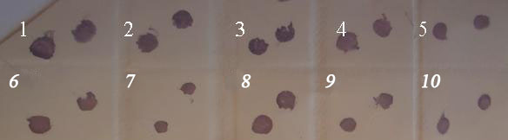

Figure 1.Nitrocellulose membrane showing tissue blot immunoassay of TYLCV-whitefly inoculated Solanum spp.

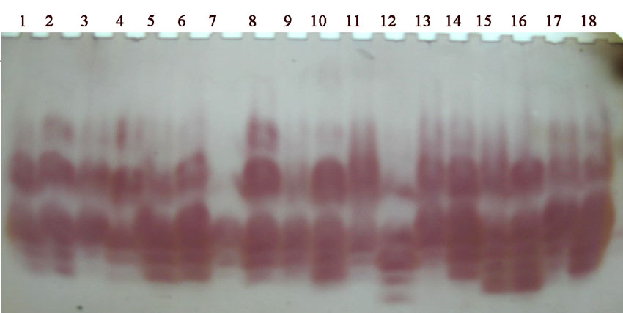

Figure 2. PPO isoforms profile in the resistant and susceptible Solanum spp induced by TYLCV compared to control.
Lanes 6, 10, 12, 14 and 16 TYLCV resistant S. chilense, S. peruvianum, S. hirsutum, S. cheesmaniae, and S . minutum, respectively.
Lanes 2, 4, 8 and 18 TYLCV susceptible S. pimpinellifolium, S. glandulos, S. penneleii and S. esculentum var Alisa, respectively.
Lanes 1, 3, 5, 7, 9, 11, 13, 15 and 17 the healthy control S. pimpinellifolium, S. glandulos, S. chilense, S. penneleii, S. peruvianum, S. hirsutum, S. cheesmaniae, S . minutum and S. esculentum var Alissa, respectively.

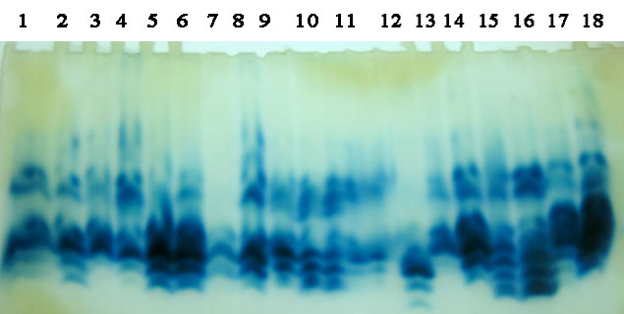

Figure 3. POD isoforms profile in the resistant and susceptible Solanum spp induced by TYLCV compared to control.
Lanes 6, 10, 12, 14 and 16 TYLCV resistant S. chilense, S. peruvianum, S. hirsutum, S. cheesmaniae, and S . minutum, respectively.
Lanes 2, 4, 8 and 18 TYLCV susceptible S. pimpinellifolium, S. glandulos, S. penneleii and S. esculentum var Alisa, respectively.
Lanes 1, 3, 5, 7, 9, 11, 13, 15 and 17 the healthy control S. pimpinellifolium, S. glandulos, S. chilense, S. penneleii, S. peruvianum, S. hirsutum, S. cheesmaniae, S . minutum and S. esculentum var Alissa, respectively.

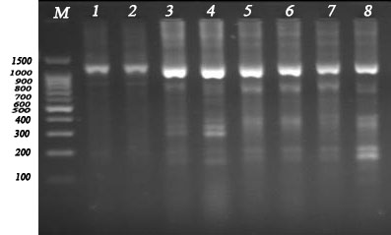
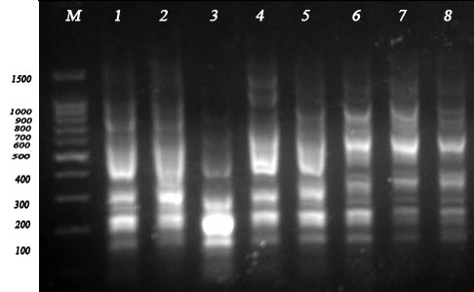

(a)

(a) (b)

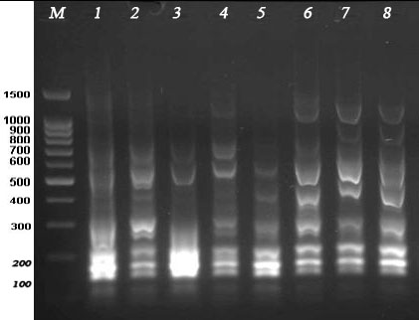
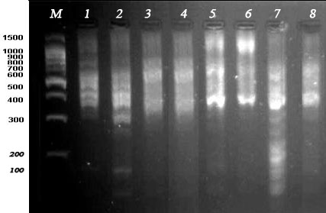

(c) (d)

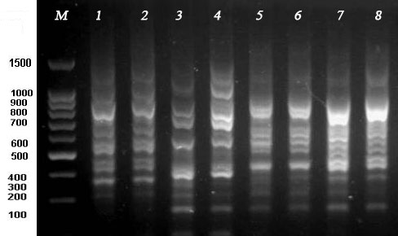

(e)

Figure 4. RAPD-PCR profiles generated by primers (a) 1, (b) 2, (c) 3, (d) 4 and (e) 5. Lane M = 100 bp DNA ladder plus, lanes 2, 4, 6 and 8 TYLCV resistant S. chilense, S. hirsutum, S. cheesmaniae and S. peruvianum, respectively compared with the healthy control S. chilense, S. hirsutum, cheesmaniae and S. peruvianum (lanes 1, 3, 5 and 7), respectively.

