Surface morphology of the ctenidia of Spondylus spinosus (Mollusca: Bivalvia) from Antalya Bay, Turkey

Deniz Akşit¹ Beria Falakalı Mutaf, Ahmet Balcı
Akdeniz University, Faculty of Aquatic Sciences and Fisheries, Antalya, Turkey
^{1.}Corresponding author: E-mail: denizaksit@akdeniz.edu.tr

Abstract Surface morphology of the ctenidia of Spondylus spinosus was studied using light and scanning electron microscopy to be compared with the gill structure of other bivalves. The demibranch of S. spinosus is heterorhabdic with the principal filaments at the descending lamellae and ordinary filaments at the ascending lamellae. The gill lamellae have a prominent gauze structure at their distal part with numerous groups of eight ordinary filaments and bore ciliary arrays on their frontal and ostia at the latero-frontal surfaces. Frequent cirral plates form regular interfilamentar junctions. The description of the gill structure of S. spinosus presented here in can be used as implications for the correlation of structure, habitat and the mode of life. Spondylus spinosus at a particular stage of its adult life could be taken as a subject for biomonitoring studies in natural and experimental environments.

KEYWORDS: Turkey, spiny oyster, ctenidia, ciliary structures, scanning electron microscopy (SEM).

INTRODUCTION
Spondylus Linnaeus, 1758 is the only genus of bivalve mollusc known in the family Spondylidae Gray 1826. Spondylus spinosus Schreibers, 1793 also known as spiny oysters are highy abundant on the shores of the Mediterranean (zenetos et al. 2003), where they live attached to the rocky substrate. As an evolutionary process in Bivalvia the gills of Spondylus perform many functions, collecting food particles and facilitating the dispersal of sex products besides their respiratory role by establishing a water current in the mantle cavity as they are part of circulatory system (goslıng 2003). In brief the gills consist of two ctenidia, each of which contain two demibranches. Each V-shaped demibranch has inner and outer components consisting of two lamellae with or without marginal grooves at their free end (goslıng 2003).
The use of bivalve molluscs to assess national marine resources and their biological status has been the subject of many extensive studies (domouhtsıdou & dımıtrıadıs 2000, davıd & fontanettı 2005, usheva et al. 2006). In Bivalve, gills and digestive glands are the first organs exposed to water and its pollutants (domouhtsidou & dımıtrıadıs 2000). Despite their abundance in the tropical and subtropical seawaters of the world, very little is known about the basic biology and ecology of Spondylus. There is very little information available on the morphology of the organs (younge 1973) although some research on reproductive biology of some species has been undertaken (vıllalejo-fuerte et al. 2002).
The main purpose of this study is to provide detailed information on the structure of the gill filaments of Spondylus spinosus, using light and scanning electron microscopy, which serve as a tool of fundamental importance in biomonitoring studies.

MATERIAL AND METHODS
Spondylus spinosus were collected from the littoral zone of the rocky shores of Antalya Bay (between 36º53′04.26′′ 36º36′25.22′′N and 31º46′31.30′′ -30º42′03.62′′E) on the southwestern coast of Turkey, where dense aggregations were found attached to the substrates. Individuals were extracted from the rocks that were detached by breaking the blocks with special sledgehammers during scuba-diving. All of the specimens were transported to the laboratory at the Faculty of Aquatic Sciences and Fisheries in Akdeniz University. Four specimens were washed, their shells opened by breaking up and washed again by sea water.
General morphology of the ctenidia of all individuals was observed using stereo light microscopy (LM). Undamaged areas of the gills were excised. Dissected specimens were studied by LM and scanning electron microscopy (SEM). Gill lamellae were fixed in Bouin’s solution for LM and in 2.5% glutaraldehyde in Sorensen’s buffer (pH 7.3, 0.1 M) for SEM. For LM specimens were cleared in xylene after rinsing in graded-ethanol series, embedded in wax. Sections of 4-7µm were stained with haematoxylen and eosin (H-E) (drury & wallıngton 1973). For SEM, dehydrated and air dried lamellae were mounted flat on aluminum stubs and coated with gold-palladium (aksıt & falakalı mutaf 2011). We examined lamellar morphology with a Zeiss Leo 1430 Scanning Electron Microscope at the Akdeniz University Medical School EM Unit (TEMGA).
The following abbreviations are used: Af.bv: afferent blood vessel, al: ascending lamella, C.a: ctenidial axis, cd: ciliary disc, ce: ciliary epithelium, dl: descending lamella, Ef.bv. Efferent blood vessel, H-E: Haematoxylen & Eosin, mg: marginal gutter, nce: non-ciliated epithelium, of: ordinary filaments, pf: principal filaments, wt: water tubule, lf: latero-frontal cilia, fc: frontal cilia, ►: ostia.

RESULTS
The ctenidia of Spondylus spinosus appears as the second largest gross anatomical structure of the visceral parts (Fig. 1A), beside the single adductor muscle. Each ctenidia of S. spinosus is formed by two V–shaped demibranchs attached to a thick ctenidial axis, the ascending lamella is one third-length shorter than the descending lamella (Fig. 1B). The branchial haemolymph vessel was prominent (Fig. 1C). There was no marginal food groove at the free distal end.
Figure 1A-C
Filaments showed different appearances on the frontal surfaces of ascending (al) and descending (dl) lamellae. Descending lamellae were thicker than the ascending. Ascending lamellae differ from the descending by the presence of minor lamellar subunits and transparent water tubules (Fig1C). The filaments of this fillibranch gill were heterorhabdic in appearance (Figs. 1, 2A-C).
On the descending lamella, thick principal filaments, consisted of two different components, a straight outer part and spirally wound cord-like inner pieces (Fig. 2A-C). The straigth branch was covered with a thick ciliary sheet. The wound portion contained more than two pieced folds, which seemed to flaunt backward to a thick poach-like appearance (Fig. 2C). No interlamellar junctions were observed.
Ordinary filaments were the only components of ascending lamellae located at the ventral part of each demibranch. Eight ordinary filaments were the continuation of every principal filament formed by divertication at the lower part of demibranch. Ordinary filaments, as translucent channels, were extending parallel and caused a fan-like expansion (Fig 2C, D). Many ordinary filaments formed a group and numerous groups in the terminal portion of the dorsal region with a flattened undulating edge which shaped a marginal gutter by folding outwardly.
Frequent ciliary discs connected every eight ordinary filaments to each other at regular intervals and extended in two directions (Figs. 2D-E). These interfilamenter connections showed a complex structure (Figs. 2F-H). Each connective disc consisted of 5-7 either cirral or microvillar plates, interlocked at the top of the other (Fig. 2H). Their location on the surface epithelium were clearly seen by light and electron microscopy (Figs. 2E-H).
Figure 2A-H
The frontal surface of the ordinary filaments showed a uniform array of cilia characterized with ciliary rootlets while abfrontal surfaces were covered with a non-ciliated epithelium, but consisted microvilli (Figs. 3A-B). The latter cells were characterized with large nucleus. The ordinary filaments were seen with abundant ciliary cover in a frontal view. The composite microcilia with elongated latero-frontal array, became clear when the filaments were inflated and expanded into interfilamentar spaces (Fig. 3C). There were no cilia differentiation. They all seemed to be simple cilia. Next to the ciliary band, irregular number of ostia were observed on the lateral surfaces (Fig. 3D). No mucus strings or layers or any lesional morphology that could be associated with environmental stress were not observed in any part of the gill lamellae.
Figure 3A-D

DISCUSSION
Light microscopy revealed that the general structure of the gills in Spondylus spinosus was partly similar to that described for other bivalves, such as Mytilidae and Pectinidae (bennınger & st jean 1997, gregory & george 2000, bennınger & decottıgnes 2008). In brief the ctenidia of Spondylus was described as Pecten type (Type B1b) without a marginal groove (atkıns 1937a & b). General morphology observed in the present study was in accordance with the previous descriptions. However, ascending lamella of Spondylus spinosus was found to be two third the size of the descending, shorter than that described for S. americanus (younge 1973).
In many bivalve species ciliation covers not only the frontal surface but also lateral surfaces of the gill and some scattered cilia were described on abfrontal surface of ordinary filaments (dufour & benınger 2001, davıd & fontanettı 2005). Only the frontal surface showed ciliary cover on ordinary filaments of the gills of S. spinosus. aıello & sleıgh (1972) suggested that the absence of ciliation provided a space for the eu-latero-frontal cilia to carry through their movement especially in Mytilus edulis, while others have suggested it was to increase the surface of material uptake from the environment by the absortive cells as in Mytella falcata (davıd et al. 2008). Retention of the food particles in filter feeding bivalves is carried out either by beating ciliary or muscular control of ostia (goslıng 2003). Spondylus spinosus seems to employ both mechanisms appearing as a sieve in many ostia next to the ciliary array. Oralward currents could mainly be in dorsal channels as described by yonge (1973) and the prominent marginal gutter in S. spinosus could be proposed being effective in particle movement since no marginal groove exists.
The regular distribution of ciliary junctions was similar as it was indicated for Mytilidae species such as Perna perna and Mytella falcata (gregory & george 2000; davıd & fontanettı 2005), but there were some differences. The ciliary discs were located on either side of ordinary filaments and extended laterally at every eight filament intervals in Spondylus spinosus. They contained a smaller number of cirral plates and were, therefore, much complex than those reported to occur in the other members of mytilid and pectinid species, such as Mytella falcata (davıd & fontanettı 2005), Modiolus barbatus (falakalı mutaf et al. 2009) and Placopecten magellanicus (morse & zardus 1997) where only single ciliary plate formed the disc. The distribution of the ciliary discs seems mainly in order to protect the filaments from hydrodynamic forces and to regulate the flow of water through interfilamentar spaces, facilitating currents in the lower part of demibranch in addition to those occuring in the dorsal channels.
Bivalve molluscs have been taken into consideration in monitoring aquatic habitats in many countries of the northern and southern hemispheres, especially those well-settled species and described as sentinel organisms in case of pollution (gregory et al. 2002). In Turkey, only a few pilot projects of this nature have been carried out for marine pollution to establish a local assessment programme or to contribute to international surveys based on the study of sedenter species, as such as Spondylus spinosus. The gill morphology has been extensively used as an indicator organ of pollution (domouhtsıdou & dımıtrıadıs 2000, gregory & george 2000, davıd & fontanettı 2005, koehler et al. 2008).
The results presented here provide data on the general structure of the gills of Spondylus spinosus with no pollution effect for a comparison at any histopathological study. Increased mucus production on gill surfaces was suggested to be as a result of an accumulation of metalic or microorganismal pollutants (gregory et al. 2002, aksıt et al. 2008). No trace of mucus was observed on the specimen studied.
In summary, the species of S. spinosus have gills with heterorhabdic filaments, of which principal ones showed a complex structure. The ascending lamellae of ordinary filaments, consist many minor lamellar subunits, are shorter than the thicker descending ones. Every eight ordinary filaments, connected with regular ciliary discs of 5-7 cirral plates, ended with a marginal gutter at the dorsal end. No marginal food groove at the free distal end was evident.
In conclusion, external morphology of the ctenidia of Spondylus spinosus can provides many useful features in evolutionary studies, and be subject of biomonitoring studies in both natural and experimental contexts.

Acknowledgements
We thank Associate Prof. m. gokoglu for providing us with specimens of Spondylus spinosus. This work was funded by the Akdeniz University Research Projects Coordination Unit.
LITERATURE CITED

aıello e. & m.a. sleıgh 1972. The metachronal wave of lateral cilia of Mytilus edulis. The Journal of Cell Biology 54: 493-506.
aksıt d.; b. falakalı- mutaf; b. gocmen; g.gurellı 2008. A preliminary observations on Trichodina sp. (Ciliophora:Pertricha) on the gills of limpets (Patella spp.) in Antalya (Turkey). North-Western Journal of Zoology 4, 295-298
aksıt d.& b. falakalı-mutaf 2011. The external morphology of the gill of Patella caerulea L. (Mollusca: Gastropoda). Turkish Journal of Zoology 35, 603-606.
atkıns d. 1937a. On the ciliary mechanisms and interelationships of lamellibranchs. Part II. Sorting devices on the gills. Quarterly Journal of Microscopical Science 78, 339-373.
atkıns d. 1937b. On the ciliary mechanisms and interelationships of lamellibranchs. Part III. Types of lamellibranch gills and their food currents. Quarterly Journal of Microscopical Science, 79, 375-421
benınger p.g. & s.d. st-jean. 1997. The role of mucus in particle processing by suspension-feeding marine bivalves: unifying principles. Marine Biology 129: 389-397.
benınger p.g. & p. decottıgnes. 2008. Worth a second look: gill structure in Hemipecten forbesianus (Adams & Reeve 1849) and taxonomic implications for Pectinidae. Journal of Molluscan Studies 74: 137-142. doi: 10.1093/mollus/eyn001
davıd j.a.o. & c.s. fontanettı. 2005. Surface morphology of Mytella falcata gıll fılaments from three regıons of the santos estuary. Brazillian Journal of Morphological Science 22: 203-210.
davıd j.a.o.; r.b. salarolı.; c.s. fontanettı. 2008. Fine structure of Mytella falcata (Bivalvia) gill filaments. Micron 39: 329-336. doi: 10.1016/j.micron.2007.06.002

domouhtsıdou g.p. & v.k. dımıtrıadıs. 2000. Ultrastructural localization of heavy metals (Hg, Ag, Pb and Cu) in gills and digestive gland of mussels, Mytilus galloprovincialis (L). Archives of Environmental Contamination and Toxicology 38: 472-478. doi: 10.1007/s002449910062
dufour s.c. & p.g. benınger. 2001. A functional interpretation of cilia and mucocyte distributions on the abfrontal surface of bivalve gills. Marine Biology 138: 295-309.
drury r.a. & e.a.wallıngton. 1973. Carleton’s Histological Technique, Fourth Edition. Oxford University Press, London UK. X+432p.
falakalı mutaf b.; d. aksıt; m. gokoglu. 2009. Scanning electron microscopy of the gill morphology of Modiolus barbatus (Bivalvia: Mollusca). XV. National Symposium of Aquatic Sciences, Rize, Turkey. (In Turkish).
goslıng e. 2003. Bivalve Molluscs. Biology and Culture. Fishing New Books, Blackwell Scientific Publications, Oxford UK. X+443p.
gregory m.a. & r.c. george. 2000. The structure and surface morphology of gill filaments in the Brown mussel Perna perna. Africa Zoology 35: 121-129.

gregory m.a.; d.j. marshall; r.c. george; anandraj a; t.p. mcclurg. 2002. Correlation between metal uptake in the soft tissue of Perna perna and gill filament pathology after exposure to mercury. Marine Pollution Bulletin 45: 114-125.
koehler a.; u. marx ; k.broeg; s. bahns; j.bresslıng. 2008. Effects of nanoparticles in Mytilus edulis gills and hepatopancreas –A new threat to marine life? Marine Environmental Research 66, 12-14.
morse m.p., j.d. zardus 1997. Bivalvia. In harrıson f.w., a.j. kohn (Eds.). “Microscopic Anatomy of Invertebrates Volume 6A: Mollusca II. . Wiley-Liss Inc., New York. 7-118 p.
sakuraı ı.& m. seto 2000. Movement and orientation of the Japanese scallop Patiopecten yessoensis (Jay) in response to water flow. Aquaculture 181: 269-279.

usheva l. n.; m. a. vaschenko; v. b. durkına. 2006. Histopathology of the digestive gland of the bivalve mollusk Crenomytilus grayanus (Dunker, 1853) from southwestern Peter the Great Bay, Sea of Japan. Russian Journal of Marine Biology 32: 166–172.

vıllalejo-fuerte m.; m arellalno-martınez; b.p. ceballos-vazquez; f. garcıa-domınguez. 2002. Reproductive cycle of Spondylus calcifer Carpenter,1857 (Bivalvia: Spondyludae) in the “Bahai de Loreto” National Park, Gulf of California. The Journal of Shellfish Research 21 :103-108.
zenetos a.; s gofas; g. russo; j. templado. 2003. CIESM Atlas of Exotic Species in the Mediterranean. Vol. 3 Molluscs (F. Briand, Ed.) CIESM Pub. Monaco. 376p.
yonge c.m. 1973. Functional morphology with particular reference to hinge and ligament in Spondylus and Plicatula and a discussion on relations with superfamily Pectinicea (Mollusca:Bivalvia). Philosophical Transactions of the Royal Society of London B 267 (883), 173-208.

FIGURE CAPTIONS
Figure 1. General appearance of the ctenidia of Spondylus spinosus. A. Ascending and descending lamellae attached at the ctenidial axis forming W shape. B. Frontal view of principal and ordinary filaments. C. Schematic drawings of the ctenidia with frontal (left) and sideway (right) view of the gill filaments.
Figure 2. SEM and LM of the ctenidia of Spondylus spinosus. A. Proximal region of a demibranch, principal filaments extending from the axis, B. View of the principal filaments at different axis, C. Ordinary filaments located at the behind of principle ones at the distal region of demibranch,D. Ordinary filaments attached by continual ciliary junctions with connective discs at regular intervals and extended inwardly (arrows) E. Ciliary discs interlocked to the next one, F. Ciliary junctions between ordinary filaments. (LM/H-E) G. Cross section at the connection area (arrow) (LM/H-E-H). H. Ciliary junction and connective disc consists 5-7 cirral plates (black arrows), interlocked each other (LM /H-E). Scale bar: A-C. 200µm, D. 60µm, E. 30µm, F-G. 100µm, H. 50 µm.
Figure 3. SEM and LM of the gill filaments of Spondylus spinosus. A. General view showing cellular organization of ordinary filaments, ciliated epithelium at only frontal surface and prominent ciliary bases B. Detail of a single filament with lateral cilia (arrow indicating ostia). C. Detail of the ordinary filaments showing the ciliary cover, D. Frontal ciliary row on the inflated filaments and scattered ostia (◄) at the lateral surface. Scale bar: A, C-D. 30µm, B. 4µm.

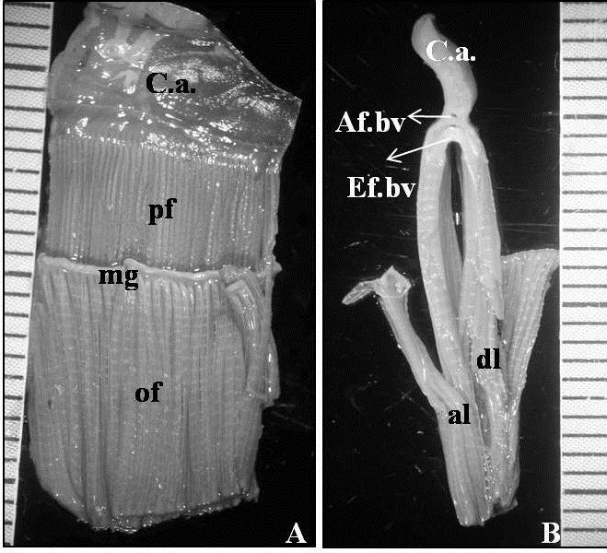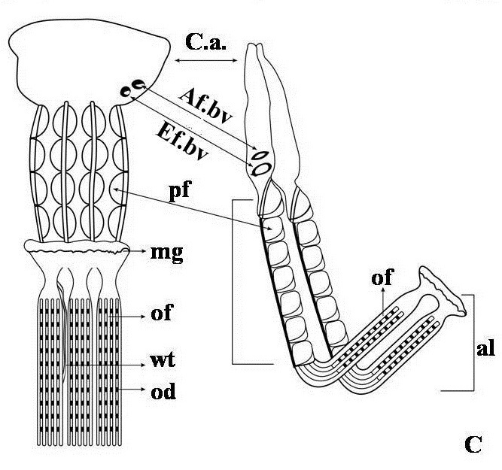

Figure 1A-C
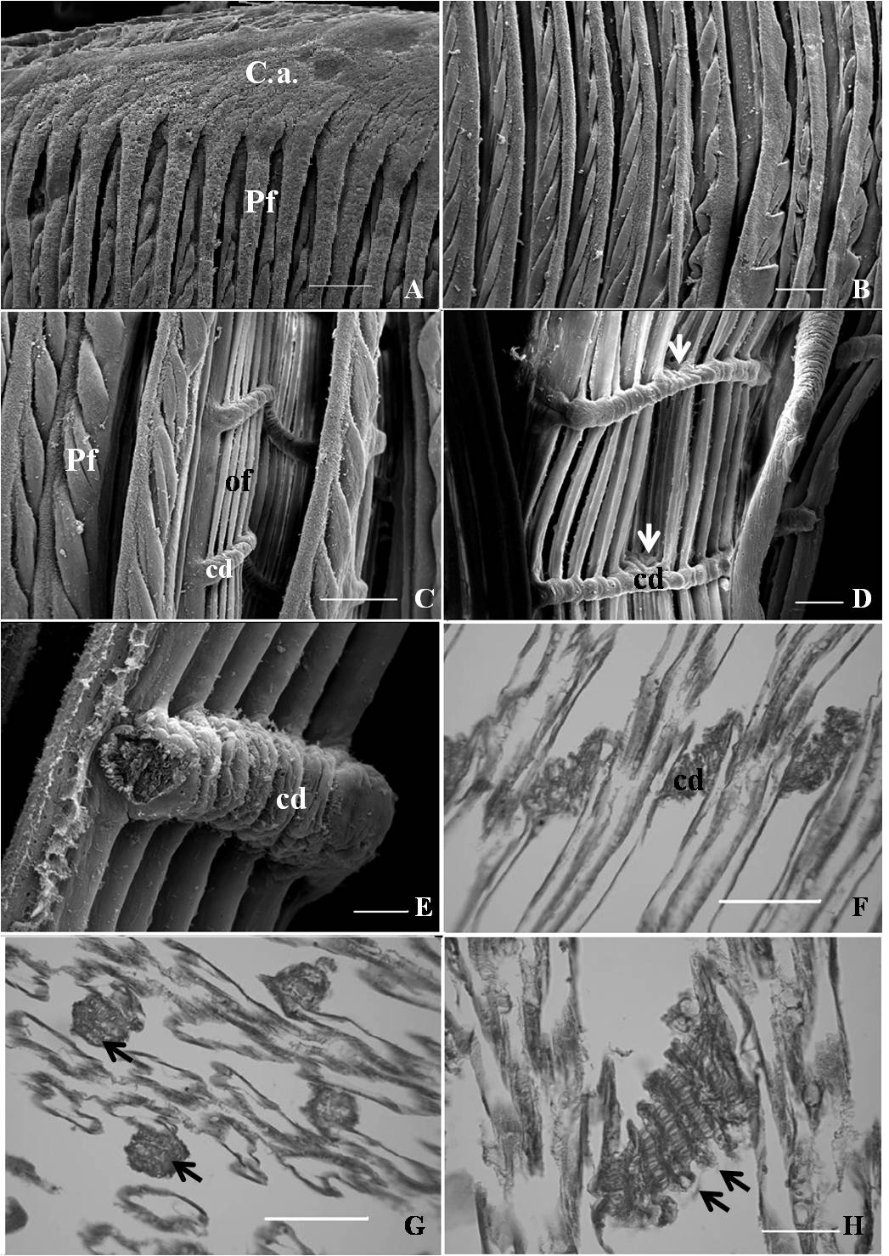

Figure 2A-H
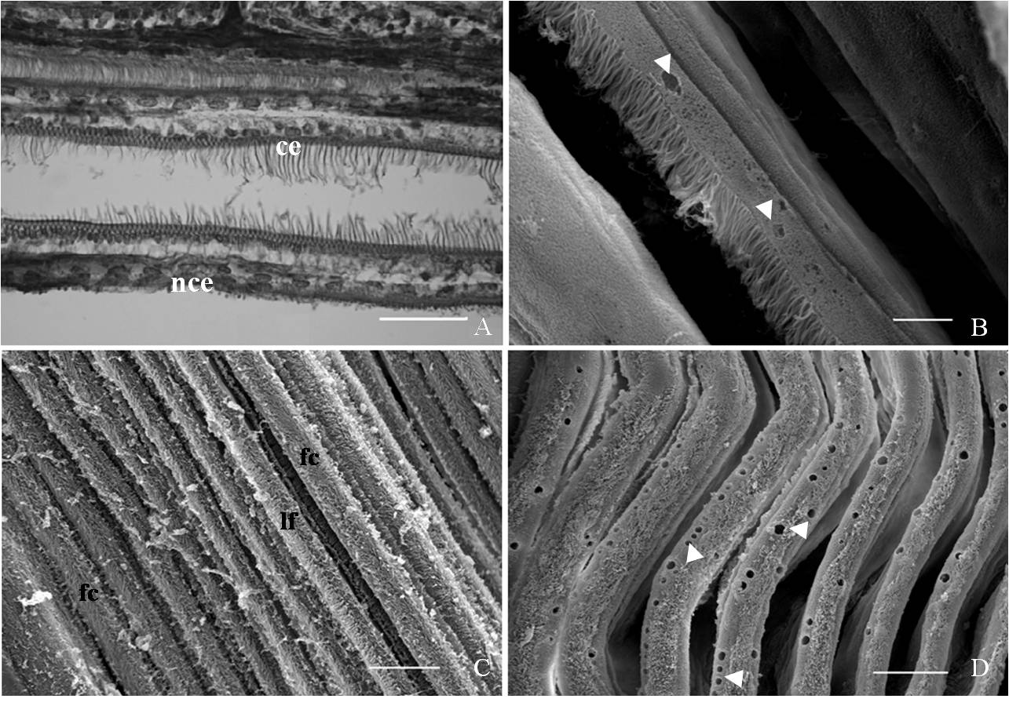

Figure 3A-D

To the reviewer 1.
We appreciate for the comments about our revised manuscript. We have tried to do some more revisions on the manuscript which we agree with you and we listed those below according to your and other reviwers indications:

Abstract: 1.We have tried to stress the main objective of our study. Yes, Spondylus is surely used as bioindicators because they become sessile in their adult life where they had sttled at their larval stage. Environmental factors effect them to choose right place for settlement. After they are settled environmental factors influence their life standarts. So their ctenidia would be the first organ to be influenced from the water quality incurrented. Study of morphology of ctenidia is, therefore very important.
In addition, a clear-cut morphology is the central relation in comparative biology. Relationship of taxa are recognized through analysis of characters.
Other reviewer suggested a short abstract.

Keywords: Turkey is replaced with morphology as suggested.

Introduction: The reason of our study is to clarify the morphology of the ctenidia of S. spinosus. Because we have already planned to study some ecological parameters in Antalya Bay, by observing the structural differences of the organisms which settled within the area and longevity is satisfactory for a long time survey.
Yes the region is getting heavily populated, so pollution increases within short periods. The organisms are getting scarce from the places where we are able to find nowadays, although they are not a most desirable food in our country and consumption is not the cause of its explotation. For instance we used to work with Patella caerulea from close-by environment few years ago, but now we have to go further places.

Material and Methods: Four animals were studied out of twenty collected (Two specimens from each sampling site at the either side of Antalya Bay). They were kept very short period in the fish tank after they brought to the laboratory. No acclimitation was considered. No anesthesia were applied. Because the hard shells were broken up to obtain the gill tissue. The figure 1 is removed, instead the particular coordinates were indicated of two collection site. The samples obtained from uncontaminated area.
Abbreviations used in the figures were given at the end of this section as suggested by the second reviwer.

Results: Letters in the figures were shown much more clearly and indication were increased. In Figure 2 (now Figure1) general morphology of the ctenidia were photographed by using stereo light microscopy. A ruler was used to indicate the dimension of the demibranch. But the schematic views of the gill filaments were not drawn at their actual length, but just to specify their structural definition.

Discussion: The statement “general morphology observed in the present study was in accordance with the previous descriptions” was removed, because the first sentence was similar statement in relation to some references. The findings of the present work were discussed by relating the results to other references and the addition to the literature was summarized in conclusion paragraph. It was tried to point out what would be done in course of future study.

Conclusion: We have tried to review the conclusions of the work as suggested. We have collected the specimen from unpolluted areas. Becuse we have not observed any trace of mucus we believe that the present descriptive study on ctenidia could be used as a key information for the comparions of the material which would be collected from any polluted environment.

References: We could reduce the number of references down to 23. But as we have increased the information in both Introduction and Discussion sections many references were cited more than once in the text. We believe the references used are quite relevant with the work.

To the reviewer 2.
We appreciate the corrections in our revised manuscript. We have tried to do some more revisions on the manuscript which we agree with you and other reviwer’s indications:

Abstract: 1.We have tried to stress the main objective of our study.
We have prefered to use the word ctenidia instead of gill in the first sentence, because it was suggested earlier by the other reviewer.

Keywords: Turkey is replaced with morphology as suggested.

Introduction: The reason of our study is to clarify the morphology of the ctenidia of S. spinosus. Because we have already planned to study some ecological parameters in Antalya Bay, by observing the structural differences of the organisms which settled within the area and longevity is satisfactory for a long time survey.

Material and Methods: Four animals were studied out of twenty collected (Two specimens from each sampling site at the either side of Antalya Bay). They were kept very short period in the fish tank after they brought to the laboratory. No acclimitation was considered. No anesthesia were applied. Because the hard shells were broken up to obtain the gill tissue. The figure 1 is removed, instead the particular coordinates were indicated of two collection site. The samples obtained from uncontaminated area.
Abbreviations used in the figures were given at the end of this section as suggested. H-E is an abbreviation for haematoxylen and eosin stains.

Results: Letters in the figures were shown much more clearly and indication were increased. In Figure 2 (now Figure1).

Discussion: The findings of the present work were discussed by relating the results to other references and the addition to the literature and they were summarized in conclusion paragraph. It was tried to point out what would be done in course of future study.

Conclusion: We have tried to review the conclusions of the work as suggested. We have collected the specimen from unpolluted areas. The present descriptive study on ctenidia could be used as a key information for the comparions of the material which would be collected from any polluted environment.

References: We have reduced the number of references on suggestion of the other reviewer. We have increased the information in both Introduction and Discussion sections many references were cited more than once in the text.

