Morphology and functional interpretation of gill in the date mussel Lithophaga lithophaga (Bivalvia: Mytilidae)

Deniz Akşit., Beria Falakalı Mutaf*
Akdeniz University, Faculty of Aquatic Sciences and Fisheries, Antalya
*Corresponding author: E-mail: fmberia@akdeniz.edu.tr

ABSTRACT: Gills of Lithophaga lithophaga consist of homorabdic filaments, a characteristic of the mytilids. The lamellae have cavities at their laterals beside their prominent ciliary structure on the frontal and lateral surfaces. Latero-frontal cilia extended in pairs, one attached to the other with a membrane and showed a composite structure. Ascending and descending lamellae, fused by fan-like cilia groups before forming food groove at their ventral margins. Scabrous blocks at the abfrontal edges of the ascending lamellae showed an appearance as food graters that the relatively large captured food particles are grinded into smaller pieces to be ingested by the date mussel. These morphological features in the gills of L. lithophaga can be used for comparison with those of other congeners or mytilids.

KEYWORDS: ciliary structures, date mussel, gill, SEM.

INTRODUCTION

Lithophaga lithophaga L. 1758 in the family Mytilidae is known as a date mussel which is a wide spread native species in the infralittoral zones of the Mediterranean, Atlantic and Red Sea (Gargominy et al. 1999, Turner & Boss 1962, El-Menif et al. 2007, Devescovi 2009). The species is one of the main boring organisms on any available calcareous substrata (Morton & Scott 1980, Gargominy et al. 1999). Bivalve gills as a functional trait, perform many functions, collecting food particles and facilitating the dispersal of gamets besides their respiratory role, by establishing a water current in the mantle cavity (Gosling 2003).
Morphological characteristics of any examined organ, such as the structure of the gills are important data in ecological studies as well as considering them for systematic and cladistic analysis. Although a number of studies on the life history and ecological aspects of the members of the genus Lithophaga (Valli et al. 1986, Scott 1988, Brickner et al. 1993, Galinou-Mitsoudi & Sinis 1994, 1995, El-Menif et al. 2007, Devescovi 2009), with limited descriptions of its general anatomy (Turner & Boss 1962, Simone & Goncalves 2006) have existed, very little has been published on its ctenidial structure (Ridewood 1903, Turner & Boss 1962). Well-documented knowledge was available on other Mytilidae genera: Mytilus, Mytella and Perna (Aiello & Sleigh 1972, David & Fontanetti 2005, David et al. 2008, Domouhtsidou & Dimitriadis 2000, Gregory & George 2000, Gregory et al.2002).
The present study aims to study descriptive and functional anatomy of the gill of Lithophaga lithophaga trying to understand the morphological adaptation and ecological aspects of the species.

MATERIAL AND METHODS
Study Area
Samples of Lithophaga lithophaga were collected from the limestone rocks at the littoral shores of the Antalya Bay (between 36º53′04.26-36º36′25.22 N and 31º46′31.30-30º42′03.62E) on the southwestern coast of Turkey (Fig.1).
Figure 1.
Materials
Dense aggregations were found bored into the substrates. Individuals were extracted from the rocks detached by breaking the blocks with special sledgehammers during scuba-diving in April 2010. Two collections were made at the site, with 4 specimens at each case. All of the specimens were transported to the laboratory at the Faculty of Aquatic Sciences and Fisheries in Akdeniz University. Four specimens were washed, their shells opened by breaking up and washed again by sea water. Undamaged areas of the gills were excised.
SEM
The gills of the specimens were fixed in Bouin’s solution, after dehydration in ethanol/amyl acetate ctenidia was critical point-dried, mounted flat on aluminum stubs, coated with gold-palladium by modification from Aksit et al. (2008) and studied using Zeiss Leo 1430 Scanning Electron Microscope (SEM) at Akdeniz University Medical School EM Unit (TEMGA).

RESULTS
Gills of Lithophaga lithophaga is a very prominent structure in general anatomy, and double set on each side of the body effectively dividing the mantle cavity into chambers. Inner and outer demibranches are approximately at the same size (Fig. 2a&b).
Figure 2.
The filaments have homorhabdic shape in appearance and ctenidial axis of the gill has a spinal ridge with a rough and ciliated surface (Fig.3a). There was a prominent canal at the dorsal end of the axial region and a dentation at the lower edge (Fig. 3a&b). Many particles, especially ciliated protozoa seemed to be trapped within the canal (Fig.3b&c).
Figure 3.
Descending lamellae were not differrent from the ascending ones and they were in intervals attached lenghtwise, showing eulamellibranch gill (Fig. 3a). The lamellae appearred as a grille screen at the abfrontal view and as a thick ciliary cover from the frontal side (Fig. 4).
Figure 4.
There was a plica formation to outline a cavity between the latero-frontal and lateral arrays of cilia along the lamella. Filaments looked like parts with lengthwise channelles from top to bottom (Fig.). Food groove was clearly visible at the free folding end of the filaments. Two levelled-ciliary discs existed at regular intervals on ascending and descending lamellae to interlock the filaments (Fig 5a&b).
Figure 5.
Free ends of the filaments were bulging slightly around the food grooves and characterized by marginal cilia. The ciliary arrangement was forming a short extreme part with a thick cover in the inner view which each had a fan of cilia settled at the bottom (Fig.6). Ascending and descending lamellae, connected by those fan-like cilia groups, extended onward as two layers from the endpiece and generally fused eventually (Fig.6).
Figure 6.
Filaments were observed to be attached by recurring ciliary junctions. Discs were formed by a condensed tufts of simple cilia which is rooted from a base extended from latero-abfrontal surfaces of the lamellae (Figs.5a&b,6-7).
Figure 7.
Ciliary cover of the filaments from the frontal side showed different cilia formations. Frontal and lateral cilia were much shorter than the latero-frontal ones (Fig. 8a). Latero-frontal cilia extended in pairs, one attached to the other with a membrane and showed a composite structure (Fig 8b). Those cilia were branched out bidirectionally along its axis and seemed to be much more effective functionaly in flowing water and collecting pieces of food. Among many particles aggregated with mucus secretion, solitary protozoa were observed to be settled on the frontal cilia (Fig 8c).
Figure 8.
The length of the filaments, varied from place to place. Three layers of brick pattern were formed by blocks with scabrous surfaces at the abfrontal edges of the ascending lamellae mainly adjacent to the marginal groove (Fig 9) and in the slits between the lamellar junctions.
These blocks showed an appearance as food graters and their surfaces were adhered with a particular matter sticking fast with mucus (Fig. 10).
Figure 9.
Figure 10.
Abfrontal surfaces of the descending lamellae, however, carried many infrequently scattered ostia at different locations in gill L.lithophaga. (Fig.11).
Figure 11.

DISCUSSION

General architecture and the arrangement of the filaments of the gills in Lithophaga lithophaga were partly similar to documented for other Mytilids, such as Perna perna, Mytella falcata, Mytilus edulis (Beninger & St Jean 1997, Gregory & George 2000, David & Fontanetti 2005), yet there is very little information on this aspect (Ridewood 1903, Turner & Boss 1962). In brief the gills consist of very prominent sheets of two ctenidia- in which the outer and inner demibranchs are very similar.
In many bivalve species, ciliation covers not only the frontal surface, but also lateral surfaces and some scattered cilia were recorded on the abfrontal surface of the filaments (Dufour & Beninger 2001, David & Fontanetti 2005). The regular distribution of ciliary junctions, formed by simple cilia, were the same as it was indicated for other Mytilidae species of Perna perna, Mytella falcata and Modiolus barbatus (Gregory George 2000, David & Fontanetti 2005, Falakalı Mutaf et al. 2009). The aligned rows of ciliary discs with their distribution pattern in Lithophaga seem to have a function mainly to protect the filaments from hydrodynamic forces and to regulate the flow of water through interfilamentar spaces. Mechanical adhesion of the ciliary junctions has previously been described by ultrastructural study of ciliary tips in scallop gills (Reed-Miller & Greenberg 1982).
Since Lithophaga buried itself in a substratum with irrevocable settlement, use incoming current as a source of O₂ and food. Bivalves have acquired a size for the gills to efficiently function to get the best of the hydrodynamics of the immediate surrounding, as it is in constant contact with water, and it is used in the feeding mode of the species (Neumann & Kappes 2003). Lithophaga, likewise seems to use its gill via two basic mechanisms to collect particles; mechanical sieving and aerosol trapping as described in many studies (Silverman et al. 1996, Dufour & Beninger 2001). The organism shows a feeding habit from a diet containing a greater proportion of minute organisms, such as protozoans, suspended in water. Symbiotic ciliated protozoan was described to dislodge from the ctenidia to the buccal region of Placopecten magellanicus (Beninger et al. 1988). Similarly, harbored ciliated protozoans in the axial canal of the ctenidia account to be an important part of nutrition in feeding of L. lithophaga. The cavities, also formed by a ciliated-plical boundary, which are connected to the food groove, suggest to increasing the maintainance of the food particles by a controlled water flow. Atkins (1937) indicated much earlier that fine particles were transported through that path. Fan-like ciliary connection between ascending and descending lamellae presumably serve to open and close the ventral groove, which is involved in transporting food particles to the labial palp (Ward et al. 1993). The structure of the fused pairs of latero-frontal cilia in L. lithophaga are thought to be effective in water current, particle capture and transport which were extensively described as a composite structure of 8-20 fused cilia in some other bivalve species (Atkins 1938, Ward et al. 1993, Silverman et al. 1996, David & Fontanetti 2005). Blocks with a scabrous surface existing in the slits next to the marginal groove and in between the tissue junctions of the lamellae are assumed to grate the large captured food particles, relative to the size of the inhalant aperture, into smaller pieces to be molded with mucus to be consumed by the date mussel. Previous workers have not reported the capability of grating of food particles finer still, although which particles are captured has been a subject of debate for many years. So, L. lithophaga has a feeding mechanism by using its gills for the collection of food particles, selecting them by size and resizing the larger ones into ingestible forms.
In conclusion, beside the characters common to mytilid bivalves, there are significant morphological features in the gill of L. lithophaga. Pairing of the latero-frontal cilia has not been decribed previously in anatomy of any other bivalve species, although no evidence has been highlighted its significance. Fan-like ciliary connection which could be effective in push and pull mechanism for the control of the holding capacity of the ventral food groove seems a reasonable assumption. The occurance of the grater blocks appears as a distinctive character beneficial to the organism for the fixed inhabitation within the limestones. These possibly unique variations in the gill of L. lithophaga can be used for comparison with samples from different substrates in which the species may inhabit and with other congeners or mytilids.

Acknowledgements

We thank Assist. Prof. E. S. Okudan for providing us with the specimens of L. lithophaga. This work was funded by Akdeniz University Research Projects Coordination Unit.

LITERATURE CITED

Aiello, E. & M.A. Sleigh. 1972. The metachronal wave of lateral cilia of Mytilus edulis. The Journal of Cell Biology 54: 493-506.
Aksit, D.; B. Falakali Mutaf.; B. Gocmen & G. Gurelli. 2008. A Preliminary observations on Trichodina sp. (Ciliophora: Peritricha) on the Gills of Limpets (Patella spp.) in Antalya (Turkey). North-Western Journal of Zoology 4: 295-299.
Atkins, D. 1937. the ciliary mechanism and interrelationships of lamellibranches. Part II. sorting devices on the gills. Quarterly Journal of Microscopical Science 79: 340-373.
Atkins, D. 1938. On the ciliary mechanism and interrelationships of lamellibranches. Part VII. Laterofrontal cilia of the gill filaments and their phylogenetic value. Quarterly Journal of Microscopical Science 80: 345-436.
Beninger, P. G.; M. Le Pennec & M. Salaun. 1988. New observations of the gills of Placopecten magellanicus (Mollusca: Bivalvia), and implications for nutrition. Marine Biology 98: 61-70. doi: 10.1007/bf 00392659.
Beninger,; P. G. & S.D. St Jean. 1997. The role of mucus in particle processing by suspension-feeding marine bivalves: unifying principles. Marine Biology 129: 389-397.
Brickner, I.; E. Kramarsky-Winter, O. Mokady & Y. Loya. 1993. Speciation in the coral-boring bivalve Lithophaga purpurea: evidence from ecological, biochemical and SEM analysis. Marine Ecology Progress Series 101: 139-145.
David, J.A.O. & C.S. Fontanetti. 2005. Surface morphology of Mytella falcata gill filaments from three regions of the santos estuary. Brazillian Journal of Morphological Science 22: 203-210.
David J. A. O.; R.B. Salaroli & C. S. Fontanetti. 2008. Fine structure of Mytella falcata (Bivalvia) gill filaments. Micron 39: 329-336. doi: 10.1016/j.micron. 2007.06.002.
Devescovi, M. 2009. Biometric differences between date mussels Lithophaga lithophaga colonizing artificial and natural structures. Acta Adriatica 50: 129-138.
Domouhtsidou, G.P. & V.K. Dimitriadis. 2000. Ultrastructural localization of heavy metals (Hg, Ag, Pb and Cu) in gills and digestive gland of mussels, Mytilus galloprovincialis (L). Archives of Environmental Contamination and Toxicology 38: 472-78. doi: 10.1007/s002449910062.
Dufour, S.C. & P.G. Beninger. 2001. A functional interpretation of cilia and mucocyte distributions on the abfrontal surface of bivalve gills. Marine Biology 138: 295-309.

El-Menif, N. T.; F. Jaafar, M. Ramdani, R. Flower & M. Boumaiza. 2007. Habitat and associated fauna of Lithophaga lithophaga (Linne 1758) in the bay of Bizerta (Tunisia). Journal of Shellfish Research 26: (2):569-574.
Falakali Mutaf, B.; D. Aksit, & M. Gokoglu. 2009. Scanning electron microscopy of the gill morphology of Modiolus barbatus (Bivalvia: Mollusca). XV. National Congress of Aquatic Sciences, Rize, Turkey. (In Turkish).
Galinou-Mitsoudi S. & A. I. Sinis. 1994. reproductive cycle and fecundity of the date mussel, Lithophaga lithophaga, (L.) (Bivalvia: Mytilidae) in Evoikos Gulf (Greece). Bios 2:17–22. doi: 10.1093/mollus/61.4.435.
Galinou-Mitsoudi, S. & A. I. Sinis. 1995. Age and growth of Lithophaga lithophaga (Linne, 1758) (Bivalvia, Mytilidae) based on annual growth lines in the shell. Journal of Molluscan also mol·lus·kan adj.Of or relating to the mollusks.n.A mollusk. ..... Studies 61:435-453.

Gargominy O.; P. Bouchet & D. Moreno, 1999. Lithophaga lithophaga (Linne, 1758). - Museum National d'Histoire Naturelle, pp. 1-5.
Gosling, E. 2003. Bivalve Molluscs. Biology and Culture. Fishing New Books, Blackwell Scientific Publications, Oxford UK.
Gregory, M.A. & R.C. George, 2000. The structure and surface morphology of gill filaments in the Brown mussel Perna perna. African Zoology 35: 121-129.
Gregory, M. A.; D. J. Marshall, R. C. George, A. Anandraj & T.P. Mcclurg. 2002. Correlation between metal uptake in the soft tissue of Perna perna and gill filament pathology after exposure to mercury. Marine Pollution Bulletin 45:114-125.

Morton, B. & P. J. B. Scott. 1980. Morphological and functional specialization of the shell, musculature and pallial glands in the Lithophaginae (Mollusca: Bivalvia). Journal of Zoology 192: 179-203.
Neumann, D. & H. Kappes. 2003. On the growth of bivalve gills initiated from a lobule-producing budding zone. The Biological Bulletin 205: 73-82.
Reed-Miller, C. & M.J.Greenberg. 1982. The ciliary junctions of scallop gills: The effects of cytochalasins and concavalin A. The Biological Bulletin 163: 225-239.
Rıdewood, W. 1903. On the Structure of the Gills of the Lamellibranchia. Philosophical Transactions of the Royal Society of London. Series B, 195:147–284.
Scott, P. J. B. 1988. Initial settlement behaviour and survivorship of Lithophaga bisulcata (D'orbigny) (Mytilidae: Lithophaginae). Journal of Molluscan also mol·lus·kan adj.Of or relating to the mollusks.n.A mollusk. ..... Studies 54: 97-108.
Silverman, H.; J.W. Lynn & T.H. Dietz. 1996. Particle capture by the gills of Dreissena polymorpha: structure and function of latero-frontal cirri. The Biological Bulletin 191: 42-54.
Simone, L.R.L. & E.P. Gonçalves. 2006. Anatomical study on Myoforceps aristatus, an invasive boring bivalve in S.E. Brazilian coast (Mytilidae). Papéis Avulsos de Zoologia. 46: 57-65.
Turner R.D. & K.J. Boss. 1962. Mytilidae. The genus Lithophaga in the Western Atlantic. Johnsonia 4: 81-116.
Valli G.; P. Nodari & R. Sponza. 1986. Experimental breeding of Lithophaga lithophaga (L.) (Bivalvia, Mytilacea) and study of the reproductive cycle in the Gulf of Trieste. Nova Thalassia 8:1–13.
Ward J.E.; B.A. Macdonald, R.J. Thompson & P.G. Beninger (1993). Mechanism of suspension feeding in bivalves: Resolution of current controversies by means of endoscopy. Limnology Oceanography 38: 265-272.

FIGURE CAPTIONS

Figure 1. Study area and its positioning in the Mediterranean waters.
Figure 2.a. General anatomy of L. lithophaga. b. Schematic view of the gills showing very prominent double sheets within the mantle cavity.
Ml: mantle layers, Mc: mantle cavity, f: foot, ea: excurruent aperture, ia: incurrent aperture, arm: anterior retractor muscle, ih: inner hemipalp, od: outer demibranches id: outer demibranches
Figure 3. Axial region of the ctenidia. a. A narrow axis and thin filaments of the gill of L. lithophaga, b. A prominent canal, full of food stuff (arrow) at the dorsal end of the axial region and a dentation at the lower edge. c.Ciliated protozoa trapped in the axial canal. Scale Bar: a . 200 µm, b. 100 µm, c. 50 µm
Figure 4. Frontal and abfrontal (arrow head) views of the demibranches of L.lithophaga. Scale Bar: 200 µm
Figure 5. Ventral end of the filaments in the gill of L. lithophaga. a. Canal formation and food grooves were very prominent. Levelled-connective-discs were at regular intervals along the filaments; b. Enlarged free end with marginal groove and duct on the surface. Scale Bar: a. 100 µm, b. 40 µm
Figure 6. Inner sides of the food grooves of the filaments in L. lithophaga with a thick ciliary head had fan-shaped ciliary connection of the lamelae. Scale Bar: 60 µm.
Figure 7. Filaments were attached by continual ciliary junctions. a.Discs interlocked to the next one by simple ciliary arrangements. b. Discs were formed by a condensed tufts of simple cilia. Scale Bar: a. 20 µm, b. 6 µm.
Figure 8. Ciliation on the filaments from the frontal view in the gill of L.lithophaga. a.Very thick three layers of cilia are prominent. b. Cilia at different length. Membranous attachments of the fronto-lateral cilia in pairs. c. Duality in fronto-lateral cilia and aggregated (arrow head) or singly distributed (small arrows) food particles on the ciliary surface. Scale Bar: a. 40 µm, b. 10 µm, c. 4 µm.
Figure 9. An ascending lamella showed a brick course on the abfrontal edges in gill L.lithophaga. Scale Bar: 20 µm.
Figure 10. Tissue blocks with toothing plane on the surface. Scale Bar: 20 µm.
Figure 11. Ostia (arrow head) distributed unevenly along the abfrontal surface of the lamellae. Scale Bar: 10 µm.

Figures
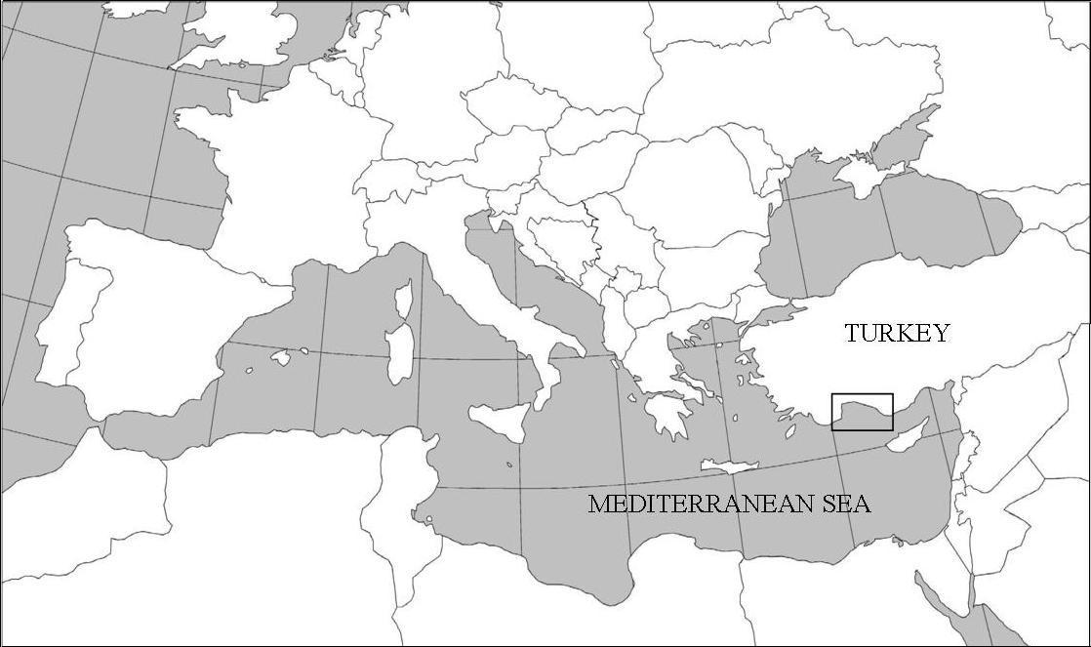
Figure 1.

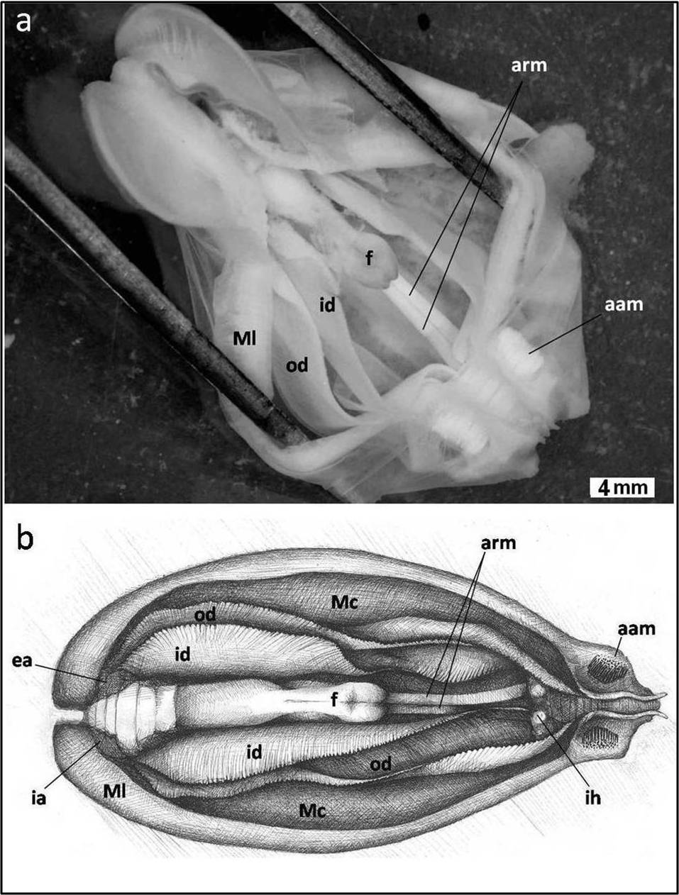
Figure 2 a-b.

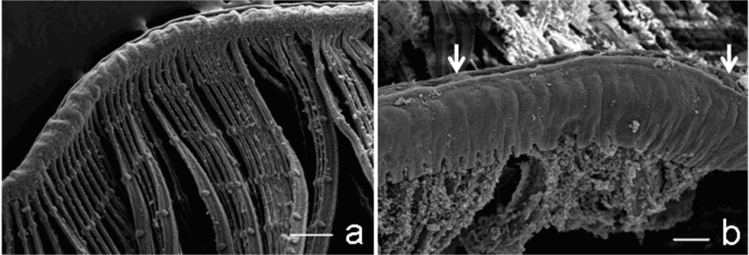
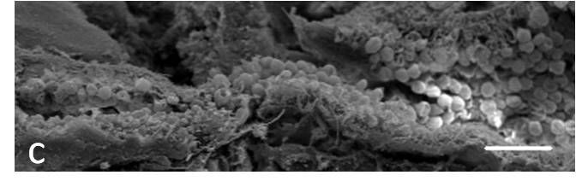
Figure 3 a- b-c.

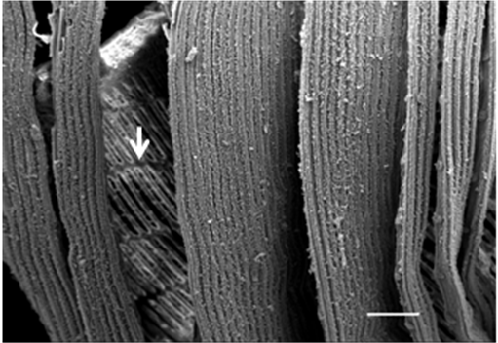
Figure 4.

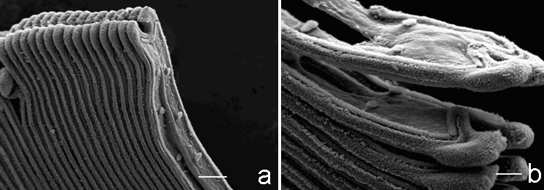
Figure 5 a- b.

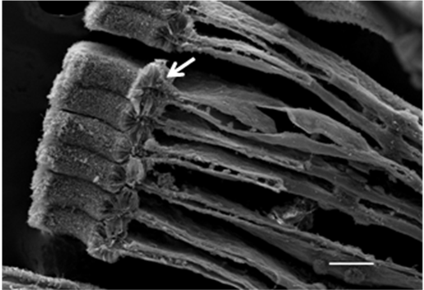
Figure 6.
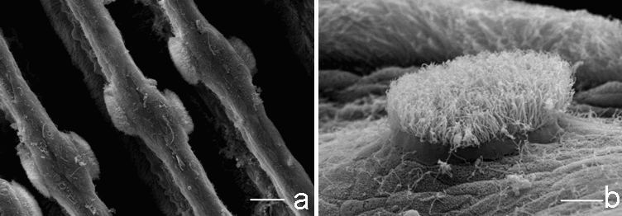
Figure 7 a-b.
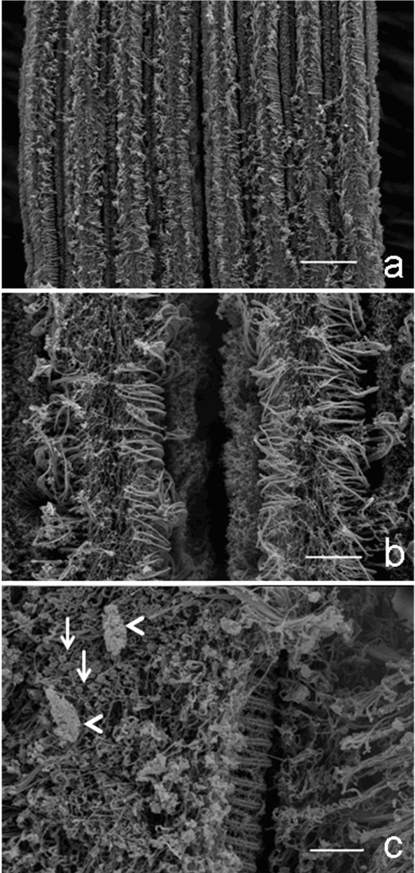
Figure 8 a-b-c.

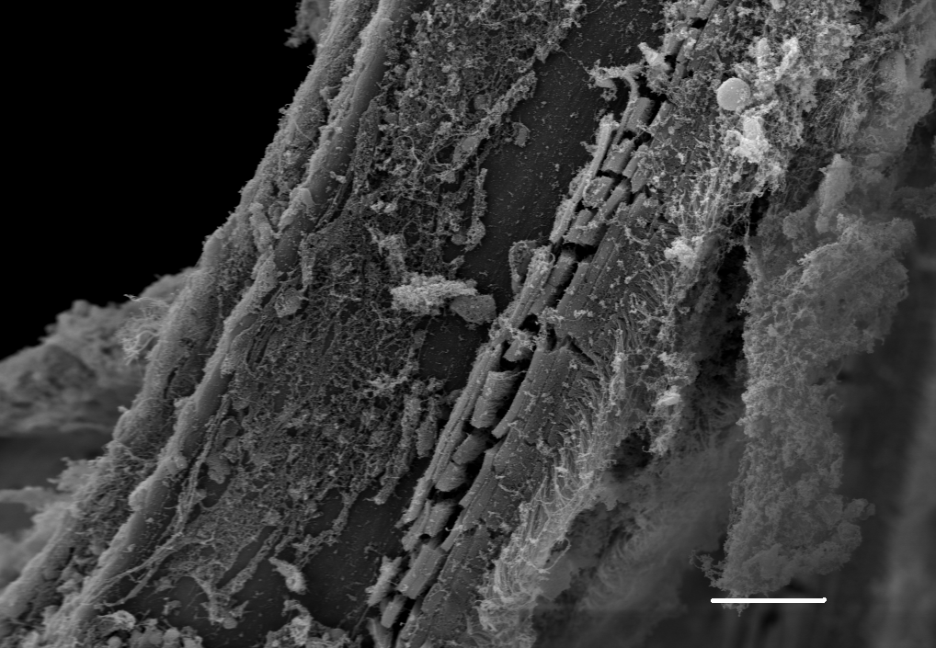
Figure 9.
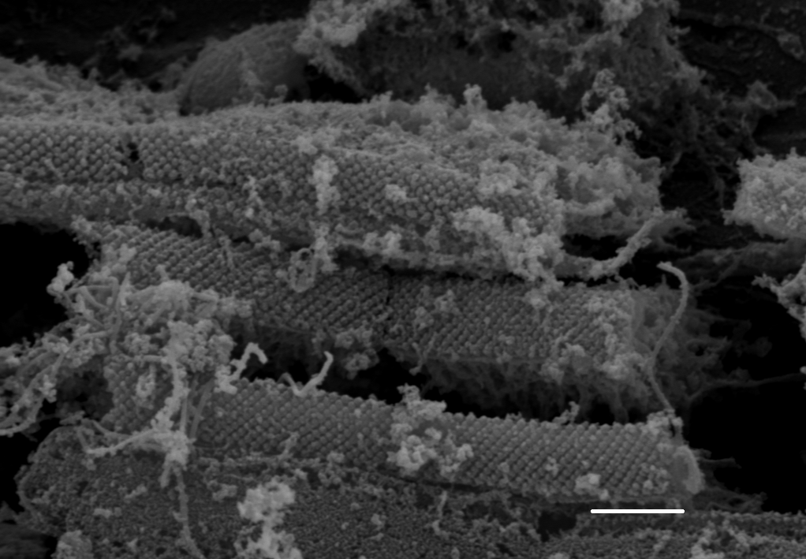
Figure 10.
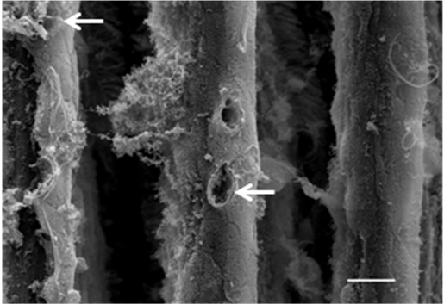
Figure 11.

