ASSESSMENT OF ANTIMICROBIAL AND PHYTOCHEMICAL POTENTIALS OF HIGH ALTITUDINAL NEPALESE LICHENS

Bikash Baral^{1*} and Bijaya Laxmi Maharjan²
¹Central Department of Botany, Tribhuvan University, Nepal
²Central Department of Microbiology, Tribhuvan University, Nepal
^{1, 2} Nepal Academy of Science and Technology, (NAST)
*Corresponding author: bikubaral@yahoo.com

Abstract
Lichens and lichen products have been used in traditional medicines for centuries. The Lichens of the high altitudinal meadow of MCA (Manaslu Conservation Area) has remained unexplored for which this research has been conducted with an aim of unveiling the phytochemical and antimicrobial properties of lichens present there. Four densely populated lichen species namely Usnea longifolia, Cetraria spp, Parmotrema reticulatum and Evernastrium nepalense were chosen for the study. The extracts of these species were obtained in 6 different solvents viz. hexane, chloroform, ethyl acetate, acetone, methanol and water by soxhlet extraction method and the antimicrobial assay was carried out by agar well diffusion method. The extract yield varied from 0.07 -29.4%. The extracts obtained showed the presence of volatile oil, saponins, coumarins and quinines, flavonic glycosides and carotenoids. The ethyl acetate fraction of E. nepalense and U. longifolia were found to be most effective against all the 8 clinical bacterial pathogens and 5 phytopathogenic fungi tested. The extracts of Cetraria spp and P. milghenensis were found to be specifically inhibiting the fungal pathogens compared to the bacterial pathogens. Generally the lichen extracts tested demonstrated antimicrobial effect which suggests a possibility of their use in reaction of various diseases caused by these and similar microorganisms.

Key-words: antibacterial, antifungal, zone of inhibition, phytochemicals

Introduction
The challenge for today’s pharmaceutical industry lies in the discovery and development of new pharmacological active molecules due to microbial resistance to available antibiotics (1). Since long back, plants have provided a source of inspiration for novel drug compounds, as plant derived medicine have made large contributions to human health and well being by becoming the natural blue print for drug discovery and the development of phytomedicines to cure diseases (2). Similar to higher plants, lichens were used since antiquity as natural drugs (3).
Lichen is a symbiotic organism consisting of a fungus (mycobiont) and a photosynthetic partner (photobiont) which can be either an alga or a cyanobacterium (4). Lichens produce a diverse range of primary and secondary metabolites (5). Slow growth and often harsh living conditions make production of protective metabolites a necessity to lichens and many secondary constituents are believed to serve as antigrowth, antimicrobial or antiherbivore agents (5, 6).
Lichen synthesizes a variety of secondary metabolites “lichen substances”, mostly from fungal metabolism (7). Lichen substances include aliphatic, cycloaliphatic, aromatic and terpenic components (8). They are extracellular products of relatively low molecular weight crystallized on the hyphal cell walls. Also, they are usually insoluble in water and can be extracted into organic solvents (9).
Screening the lichens has revealed the frequent occurrence of metabolites with antibiotics, antimycobacterial, antiviral, anti-inflammatory, analgesic, antipyretic, antiproliferative and cytotoxic properties. Even though these manifold activities of lichen metabolites have now been recognized, their therapeutic potential has not yet been fully explored and thus remains pharmaceutically unexploited (10).The present study unveils the phytochemicals present and the antibacterial and antifungal activity of the four different lichens from high altitude of Manaslu Conservation Area.

Materials and Methods
Study site and sample collection
The lichen specimens Usnea longifolia, Cetraria spp, Palmelia milghenensis and Evernastrium nepalense were harvested from alpine meadows of Manaslu Conservation Area in the autumn of year 2010. Various flora books and experts of the sample field were consulted for identification of samples (11, 12, 13, 14). Voucher samples were prepared and deposited in the Tribhuvan University Central Herbarium (TUTH) for reference.

Extraction
The harvested samples were air dried and were pulverized to powder. Each powdered samples were soxhlet extracted in different solvents, vis., hexane, chloroform, ethyl acetate, acetone, methanol and water differing in polarity. The extracts obtained were concentrated to dryness using Rotary vacuum evaporator (15).The yield of respective extract was calculated as:
Percentage yield (%) = (dry weight of extract/dry weight of samples) x100

Phytochemical screening
The presence of several chemical compounds in the various fractions of extracts obtained from different lichen species were screened by the chemical tests (16).

Antimicrobial assay
The antimicrobial assay was performed using agar well diffusion method (17). The antibacterial testing was carried out against 8 different human pathogenic bacteria i.e. Staphylococcus aureus, Escherichia coli, Salmonella Typhi, Salmonella Paratyphi, Salmonella typhimurium, Pseudomonas aeruginosa, Schigella sp, and Klebsiella pneumoniae on Muller Hinton Agar. The standard culture inoculum for each bacterial species comparable to Mac Farland 0.5 standard was prepared for the test. Similarly, the antifungal testing was done against 5 different plant pathogenic fungi i.e. Fusarium oxysporum, F. moniliforme, F. erdiforme, F. porliferatum and Exserhilium turticum on Potato Dextrose Agar. The standard culture inoculum for each fungal species was prepared on Potato Dextrose Broth with adjusting to a range of 1×10⁶ - 5×10⁶ spores/ml (18).
The antimicrobial activity was evaluated by measuring the inhibition zone diameter observed after incubating the media plates (at 37±1⁰C for 24 h and 27±1⁰C for 3-4 days for bacteria and fungi resp.) swabbed with the respective microbial strains and loading the different fractions of the extracts (50 µl of 100 mg/ mL) into the punched wells in media. To every sample tested, a set of control was run parallel.

RESULT

The yield percentage of the various fractions of the lichen extracts has been shown in Table 1. The extract yield varied from 0.07-29.4%. The phytochemical constituent in the tested lichens has been summarized in table 2. The volatile oil, saponins, coumarins and quinines were present in all the lichens tested. Flaconic glycosides was present in all the lichens except Cetraria spp while carotenoids was absent in E. nepalense.
The antimicrobial activity of the various fractions of the 4 different lichen species against the tested microorganisms was estimated on the basis of presence or absence of inhibitory zones and the results are depicted in the tables 4 and 5. Different fractions of the various lichen extracts exhibited different degrees of antibacterial and antifungal activity. The ethyl acetate fractions of E. nepalense and U. longifolia were found to be most effective against all the tested 8 bacterial pathogens. The inhibition zones of tested bacterial strains E. nepalense have been found as 9-21 mm and that of U. longifolia as 7-14 mm. the extracts of Cetraria spp were found to be at least effective inhibiting only the 4 tested bacteria while the extracts of P. milghenensis showed the activity against all the tested bacteria except Salmonella typhimurium. All the fungal pathogens tested were inhibited by one or more fractions of the lichens extracts tested and the inhibition zone ranged from 7-23 mm. The ethyl acetate fraction of E. nepalense and U. longifolia were found to be effective towards the fungal pathogens compared to the other fractions. The extracts of Cetraria spp and P. milghenensis were found to be specifically inhibiting the fungal pathogens compared to the bacterial pathogens. The different fractions of the lichens except the aqueous showed the broad antimycotic activity against the tested fungal pathogens. The ability of the extracts to inhibit the growth of several bacterial and fungal species is an indicator of the broad spectrum antimicrobial potential of different lichens which makes them a candidate for bioprospecting for antibiotic and antifungal drugs.

DISCUSSION AND CONCLUSION
Plants are known to produce certain bioactive molecules which react with other organism in the environment including bacterial or fungal growth. Lichens which are the symbiotic organisms of fungi and algae synthesize numerous metabolites, the lichen substances which comprise amino acid derivatives, sugar alcohols, aliphatic acids, macrocyclic lactones, mono-cyclic aromatic compounds, quinines, chromones, xanthones, dibenzofuranes, depsides, depsides, depsidones, depsones, terpenoids, steroids, carotenoids and diphenyl ethers (19, 20).
In the study, the lichens Usnea longifolia, Cetraria spp, Palmelia milghenensis and Evernastrium nepalense were extracted in the six solvents viz. hexane, chloroform, ethyl acetate, methanol, acetone and water. There was a variation in the extract yield of the different lichens in the various solvents which indicated the variation in their chemical constituents that was shown by the phytochemical tests. The antimicrobial activities were produced in different extents by the various fractions of the four different lichens studied. According to the result, it is shown that the antimicrobial inhibition vary with the different types of the lichens, the solvent used for extraction and the microbes tested. The ethyl acetate fraction was found to be more effective against the pathogens tested which was similar as compared to the result obtained by Chao et al. (21). Flavonoids, a phytoconstituent in most lichens exhibit a wide range of biological activities like antimicrobial, anti-inflammatory, anti-angionic, analgesic, anti-allergic, cytostatic and antioxidant properties (22).

The previous studies carried out by Rowe et al. (23), Burkholder et al. (24) and Silva et al. (25) indicated that the lichens inhibit mostly Gram positive bacteria. Even though most of the lichens have been reported to be active against Gram positive bacteria, but it is of great interest to note that the extracts of E. nepalense and U. longifolia equally inhibited the growth of both Gram negative and positive bacteria. Numerous tests proved that the bacteria are more sensitive to antibiotics compared to fungi. The reason of difference in sensitivity between bacteria and fungi can be found in different transparency of the cell wall (26). The study done by Marijiana et al (27) reported the fungi to be more resistant towards lichen extracts than bacteria. But the present study revealed that the lichen extracts showed the strong antifungal activity. The extracts of Cetraria spp and P. milghenensis showed the specific antifungal activity while least or ineffective toward bacterial pathogens. Kumar et al. (28) and Ullah et al. (29) also demonstrated antifungal activity of lichens. Isodivaricatic acid, 5-propylresorcinol, divaricatinic acid and usnic acid have been identified as antifungal agents (30).

Earlier studies revealed that the aqueous extracts of tested lichens did not show any antimicrobial activity (31, 32, 6, 27). This is probably because the active components produced by lichens are either insoluble or poorly soluble in water. The obtained results showed that the tested lichen extracts demonstrated a significant antimicrobial activity relative to the tested bacteria and fungi, which could be of significant in therapy of human and plant diseases. The wide variety of biological activities of lichens is generally correlated with their special ecological niche and with the production of metabolites that are involved in their antimicrobial actions. Further investigations on the antimicrobial activity as well as the economical and fast isolation of the metabolite from the lichens are needed. Consequently, the antimicrobial effect of plants tested can be explained with new studies by testing other microbes and conducting the pharmacological tests. Further, research for search and isolation of the lichen metabolites, greater detail investigation in the action of lichen substances for their application is essential.

References
1. Bahera, B.C.; Verma N.; Sonone, A. and. Makhija, U (2005). Antioxidant and antibacterial activities of lichen Usnea ghattensis in vitro. Biotechnol. Letter. 27: 991-995.
2. Iwu, M. (1993). Handbook of African Medicinal Plants. CRC press, Boca Raton, FL.
3. Barner, J. (2000). Pharmacognosy in the 21st century. Pharm. J. 264: 701-703.
4. Ahmadian, V. (1993). The lichen symbiosis. John Wiley and sons.
5. Hale, Me. (1983). The biology of lichens. Third edition. Edward Arnold, London.
6. Rankovic, B.; Misjic, M. and Sukdolak, S. (2008). Antimicrobial activity of substances derived from the lichens Physcia aipolia, Umbilicaria polyphylla, Parmelia caperata and Hypogymnia physodes.. World J. Microbiol. and Biotechnol. 24: 1239-1242.
7. Brenan, J.; Vaden, M.; Lester, C.; Crixell, S.; and Vattem, A. D. (2009). Biological activity of some common lichens. FASEB J. 23: 716.10.
8. Chand, P.; Singh, M. and Rai, M. (2009). Antibacterial activity of some Indian lichens. J. Ecophysiol. Occup. Health. 9: 23-29.
9. Otzurk, S.; Guvenc, S.; Arikan, N. and Yylmaz, O. (1999). Effect of usnic acid on mitotic index in root tips of Allium cepa L. Lagascalia. 21(1), 47-52.
10. Muller, K. (2002). Pharmaceutically relevant metabolites from lichens. Applied Microbiol. and Biotechnol. 56(1/2), 9-16.
11. Purvis, O.W.; Coppins, B. J.; Hawksworth, D. L.; James, P. W. and Moore, D. M. (1992). The lichen flora of Great Britain and Ireland. Natural History Museum Publications in association with the British Lichen Society, London, pp: 1-710.
12. Wirth, V. (1995). Die Flechten. Baden. Wurttembergs, Teil 1, 2 Ulmer, 1-1006. Stuttgart.
13. Dobson, F. (2000). Lichens: An Illustrated Guide. The Richmond Publishing Co. Ltd., England.
14. Poelt, J. and Vezda, A. (1981). Bestimmungsschlussel. Europaischer Flecten, Erganzungsheft II. Bibliotheca Lichenologica. Bd. 16. Cramer, Vaduz, pp: 1-390.
15. Tiwari, K. S.; Malhotra, S. N. and Vishnoi, N. K. (1992). A textbook of organic chemistry. Second edition, Vikas publishing house pvt. ltd.
16. Harborne, J. B. (1998). Phytochemical Methods- A Guide to Modern techniques of Plant Analysis. Chapman and Hall, London. Pp: 182-190.
17. Dingle J.; Red, W. W. and Solomons, G. L. (1953). The enzymatic degradation of pectin and other polysaccharides, applications of the cup assay method to the estimation of enzyme. J. of Science, food and agriculture, 40: 149-53.
18. Aberkene, A.; Cuenca-Estrella, M.; Gomez-Lopez, A.; Petrikkou, E.; Mellado, E.; Monzon, A.; Rodriguez-Tudela, J. L. and the Eurofung Network.(2002). Comparative evaluation of two different methods of inoculum preparation for antifungal susceptibility testing of filamentous fungi. Journal of Antimicrobial Chemotherapy. 50(5),719-722.
19. Clix, J.A.; Whitton, A. A.; Sargent, M. V. (1984). Recent progress in the chemistry of lichen substances. Prog. Chem. Org. Nat. Prod. 45: 207-211.
20. Fiedler, P.; Gambaro, V.; Garbarino, J. A. and Quihot, W. (1986). Epiphorellic acids 1 and 2, two diaryl ethers from the lichen Cornicularia epiphorella. Phytochemistry. 25: 461-465.
21. Chao, Y.; Xiu, J. Z.; Yuan D.D.; Yu, H. G.; Li, Y. S.; Qiang, R. and Zun, T. Z.. (2010). Antimicrobial compounds and other constituents of Evernia divaricata (L.) Ach. J. Chem. Soc. Pak.. 32 (2), 189-193.
22. Rankovic, B.; Misjic, M. and Sukdolak, S. (2007). Evaluation of the antimicrobial activity of the lichens Lasallia pustulata, Parmelia sulcata, Umbilicaria crustulosa and Umbilicaria cylindrical. J. Microbiol. 76: 723-727.
23. Rowe, J.G.; Saenz, M. T. and Garcia. 1989. Contribution a a’l e’ tudedel’ activite antibacterienne de queques lichens du sudde l’Espagne. Pharmaceutique francaise. 47: 89-94.
24. Burkholder, P. R., Evans, A.W., McVeigh, I. and Thornton, H. K. (1944). Antibiotic activity of lichens. Proceedings on National Academic Science, USA. 30(9), 250-255.
25. Silva, D.A.; Oliveira, J.; Maileite, J. E.; Queiroz, M.; Paulo and Filho L. X. (1986). Antimicrobial activity of Brazilian lichens. Biological Society Broteriana. 59(C), 87-96
26. Yang, Y. and Anderson, E. J. (1999). Antimicrobial activity of a porcine mycloperozidase against plant pathogenic bacteria and fungi. J. Appl. Microbiol. 86: 211-220.
27. Marijiana, K.; Branislav, R. and Sukdolak, S. (2010). Antimicrobial activity of the lichen Lecanora frustulosa and Parmeliopsis hyperopta and their divaricatic acid and zeorin constituents. African J of Microbiol. Research. 4(9), 885-890.
28. Kumar, S. V. P.; Kekuda, T. R. P.; Vinayaka, K. S.; Swathi, D.; Mallikarjun, N. and Nishanth, B. C. (2010). Studies on proximate composition, antifungal and anthelmintic activity of a macrolichen Ramalina hossei H. Magn and G. Awasthi. Int. J. of Biotech. & Biochem. 6 (2), 193-203.
29. Ullab, M. O.; Sultana, S.; Haque, A. and Tasmin, S. (2009). Antimicrobial, Cytotoxic and Antioxidant activity of Centella asiatica. European J. of Scientific Research. 30 (2), 260-264.

30. Schmeda-Hirschmann,G.; Tapia. A.; Lima. B.; Pertino. M.; Sortino. M.; Zacchino, S.; Rojas de Arias, A. and Feresin, G. E. (2008). A new antifungal and antiprotozoal depside from the andean lichen Protousnea poeppigii. Phytotherapy Researc., 22(3), 349-355.
31. Yilmaz, M.; Ozdemir Turk, A.; Tay, T. and Kivac, M. (2004). The antimicrobial activity of extracts of the lichen Cladonia foliacea and its (G)-usnic acid, atranorin and fumaprocetraric acid constituents Verlag der Zeitschrift fur Naturforschung. 59: 149-254.
32. Tay, T.; Ozdemir Turk, A.; Yilmaz, M. and Kivac, M. (2004). Evaluation of the antimicrobial activity of the acetone extracts of the lichen Ramalina farinaceae and its (+)-usnic acid and procetraric acid constituents Verlag der Zeitschrift fur Naturforschung. 59(C), 384-388.

Tables
Table 1. Yield percentage of the different fractions of various lichen extracts

Lichen species |  | Extracts obtained in solvents (%)
 |  | Hexane | Chloroform | Ethyl acetate | Methanol | Acetone | Water
E. nepalense |  | 13.8 | 0.07 | 1.5 | 9.7 | 0.9 | 2.2
U. longifolia |  | 29.4 | 3.4 | 2.2 | 17.2 | 1.03 | 25.5
Cetraria spp |  | 12.2 | 2.3 | 1.1 | 16.5 | 0.8 | 3.9
P. milghenensis |  | 10.8 | 2.9 | 1.1 | 5.6 | 1.02 | 9.05

Table 2. Qualitative phytochemical screening of methanolic plant extracts

Phytochemicals |  | Lichen species studied
 |  | E. nepalense | U. longifolia | Cetraria spp | P. milghenensis
Volatile oil |  | + | + | + | +
Sterol and triterpenes |  | - | - | + | +
Carotenoids |  | - | + | + | +
Fatty acids |  | - | - | - | +
Polyoses |  | + | - | - | +
Saponins |  | + | + | + | +
Polyphenols |  | - | - | - | -
Red. compound |  | - | - | - | -
Alkaloids |  | - | - | - | -
Glycosides |  | - | - | - | -
Quinones |  | + | + | + | +
Anthocyanosides |  | - | - | - | -
Anthracyanosides |  | - | - | - | -
Flavonic glycosides |  | + | + | - | +
Coumarins |  | + | + | + | +

Table 3. In-vitro growth of Inhibition zones of some bacteria in crude extracts of different lichens

Lichens | Solvents used | Diameters of ZOI of microorganisms (mm) (100 mg/mL)
 |  | S. aureus | E. coli | K. pneumonia | P. aeruginosa | S. Paratyphi | S. typhi | S. typhimurium | Schigella sp
E. nepalense | Hex | - | 9 | - | - | - | - | - | -
 | Chl | 8 | - | 8 | - | - | - | - | 11
 | EtoAc | 20 | 11 | 18 | 21 | 17 | 19 | 16 | 19
 | Met | - | 19 | - | - | - | - | - | -
 | Ace | - | - | - | - | - | - | - | -
 | Aq | - | 9 | - | - | - | - | - | -
U. longifolia | Hex | 7 | - | 7 | 9 | - | - | - | -
 | Chl | 9 | 7 | 8 | 10 | 7 | 9 | 9 | 7
 | EtoAc | 12 | 14 | 10 | 13 | 10 | 13 | 11 | 10
 | Met | 8 | - | 7 | 8 | 7 | 8 | 8 | 8
 | Ace | - | - | 8 | 8 | - | 7 | 7 | 7
 | Aq | - | - | - | 8 | - | 7 | 7 | 7
Cetraria spp | Hex | - | - | - | - | - | - | - | 6
 | Chl | 7 | - | - | - | - | - | - | 6
 | EtoAc | 7 | - | - | - | - | - | - | 7
 | Met | 6 | - | - | - | - | - | - | -
 | Ace | 7 | 6 | 6 | - | - | - | - | -
 | Aq | - | - | - | - | - | - | - | -
P. milghenensis | Hex | 6 | - | 10 | - | 6 | 8 | - | -
 | Chl | 6 | - | 8 | 7 | 6 | 8 | - | -
 | EtoAc | 8 | 8 | 8 | 8 | 8 | 6 | - | 8
 | Met | - | - | - | - | - | - | - | -
 | Ace | 7 | 6 | - | 6 | 10 | - | - | 9
 | Aq | - | - | - | - | - | - | - | -
Hex: Hexane; Chl : Chloroform; EtoAc: Ethyl Acetate; Met: Methanol; Ace: Acetone; Aq: Aqueous
Values are means of three replicates

Table 4. In-vitro growth of Inhibition zones of some fungi in crude extracts of different lichens

Lichens | Solvents  used | Diameters of ZOI of microorganisms (mm), (100 mg/mL)
 |  | E. truticum | F. erdiforme | F. oxysporum | F. moniliforme | F. proliferatum
E. nepalense | Hex | - | - | - | - | -
 | Chl | - | 10 | 11 | 11 | 15
 | EtoAc | 14 | 19 | 13 | 13 | 17
 | Met | 12 | - | 12 | 12 | 13
 | Ace | 9 | - | - | - | 12
 | Aq | - | - | - | - | -
U. longifolia | Hex | - | - | 8 | 11 | -
 | Chl | - | - | 15 | 9 | 14
 | EtoAc | 14 | 19 | 23 | 14 | 20
 | Met | - | 9 | 14 | 11 | 13
 | Ace | - | - | 9 | 13 | -
 | Aq | - | - | - | - | -
Cetraria spp | Hex | 8 | 16 | - | 11 | 16
 | Chl | - | 14 | 8 | 14 | 13
 | EtoAc | - | - | - | 9 | 8
 | Met | - | - | - | - | -
 | Ace | - | 19 | - | 9 | 12
 | Aq | - | - | - | - | 9
P. milghenensis | Hex | - | 12 | 11 | 9 | 7
 | Chl | 10 | 12 | 12 | 14 | 9
 | EtoAc | 9 | 18 | 14 | 19 | 13
 | Met | 8 | 12 | 8 | 9 | -
 | Ace | 8 | 21 | 18 | 17 | 11
 | Aq | - | - | - | - | -
Hex: Hexane; Chl : Chloroform; EtoAc: Ethyl Acetate; Met: Methanol; Ace: Acetone; Aq: Aqueous
Values are means of three replicates
Photoplates
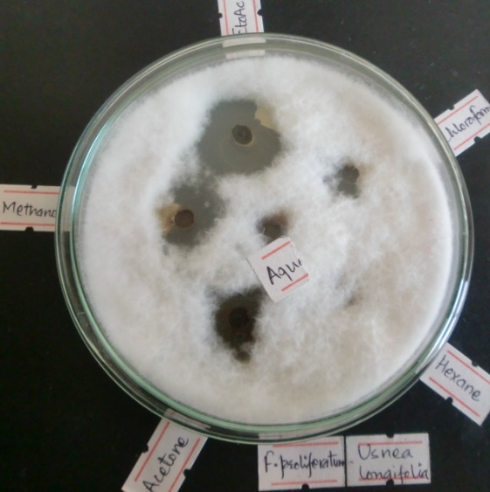 | 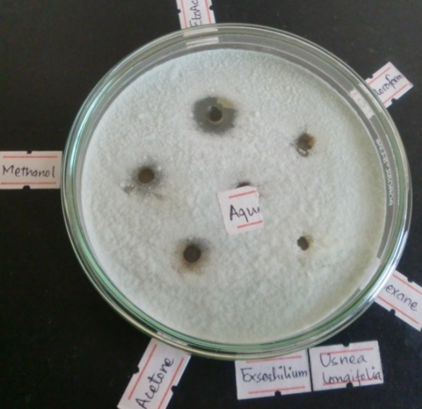
1. Plate showing antifungal activity against F. proliferatum by extracts of Usnea longifolia after incubation at 27±1⁰C for 4 days | 2. Plate showing antifungal activity against E. turticum by extracts of Usnea longifolia after incubation at 27±1⁰C for 4 days
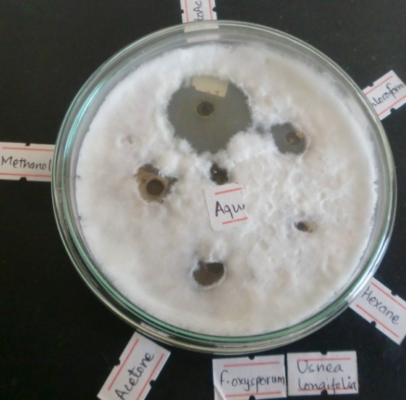 | 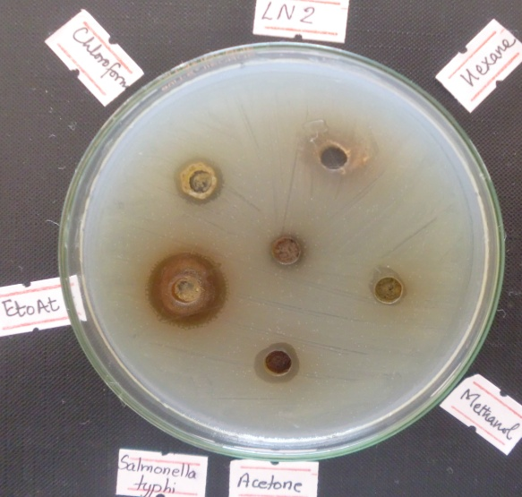
3. Plate showing antifungal activity against F. oxysporum by extracts of Usnea longifolia after incubation at 27±1⁰C for 4 days | 4. Plate showing antibacterial activity against S. Typhi by extracts of Usnea longifolia after incubation at 37±1⁰C for 24 h
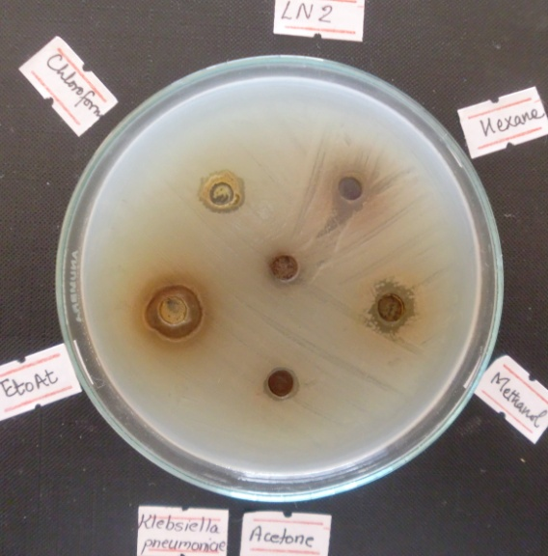 | 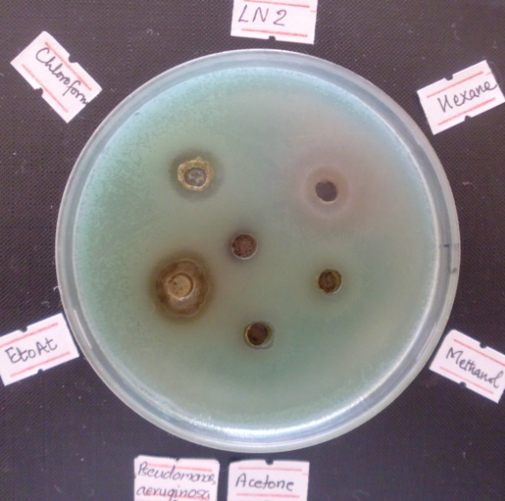
5. Plate showing antibacterial activity against K.pneumoniae by extracts of Usnea longifolia after incubation at 37±1⁰C for 24 h | 6. Plate showing antibacterial activity against P.aeruginosa by extracts of Usnea longifolia after incubation at 37±1⁰C for 24 h

