*Table 1. Different Definitions of Non-response Based on Measures of Disability Increase and/or Relapse Rate after 1 Years of Follow-up in Patients Treated with Interferon-beta.*

*Non responder definitions*

*A* An increase of at least one EDSS stepconfirmed at 1 year.

B Presence of any relapse confirmed at 1 year.

C Presence of two or more relapses confirmed at 1 year.

D A decrease in relapse rate less than 50% compared with 1 year before therapy.

E No decrease or higher relapse rate compared with 1 year before therapy.

F Definition A or B.

G Definition A + B.

EDSS = Expanded Disability Status Score

*Table 2. Demographics and baseline clinical characteristics of patients according to the responder status for the different definitions adapted from Rio et al.,10*

**MS DURATION EDSS**

**DEFINITIONS R x NR % PATIENTS AGE (yr) a SEX BASELINE Relapsesb BASELINE**

**BASELINE %female (months) (mean) (mean)**

A R 96,7 30,6 74 64,6 1,5 2.6

NR 3,3 19,3 100 31,2 2 4.0

B R 57,1 32 73 59,7 1,3 2.6

NR 42,9 28 77 68,5 1,7 2.7

C R 87,9 31 74 61,0 0,4 2.7

NR 12,1 25 82 79,7 2,4 2.6

D R 62,6 29,4 77 57,6 1,8 2.5

NR 37,4 31,7 71 73,3 0,9 3.0

E R 76,9 29,9 77 64,4 1,6 2.6

NR 23,1 31,4 67 60,3 1,0 2.7

F R 57,1 32 73 59,7 1,3 2.6

NR 42,9 28 77 68,5 1,7 2.7

G R 96,7 30,6 74 64,6 1,5 2.6

NR 3,3 19,3 100 31,2 2,0 4.0

R = Responders NR = nonresponders

aAge (baseline)

bRelapses in the one year before INFβ and GA therapy

*Table 3. Characteristics of patients included and stratified according to ethnicity, gender, age of onset and time of the disease until the beginning of immunomodulator.*

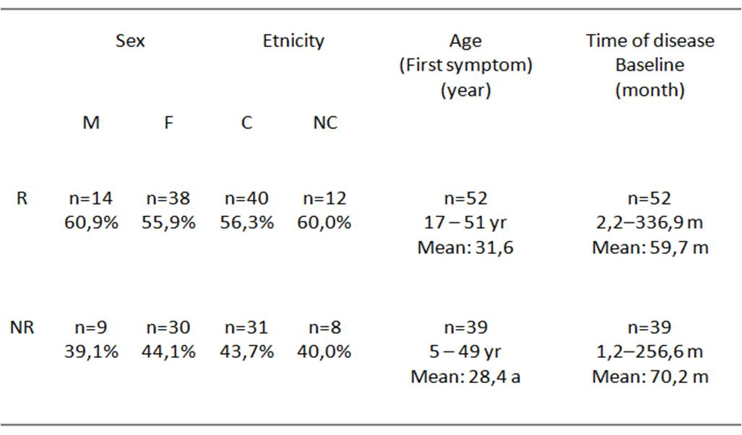

R = Responders NR = nonresponders

M = Male F = Female

C = Caucasian NC = Non caucasian

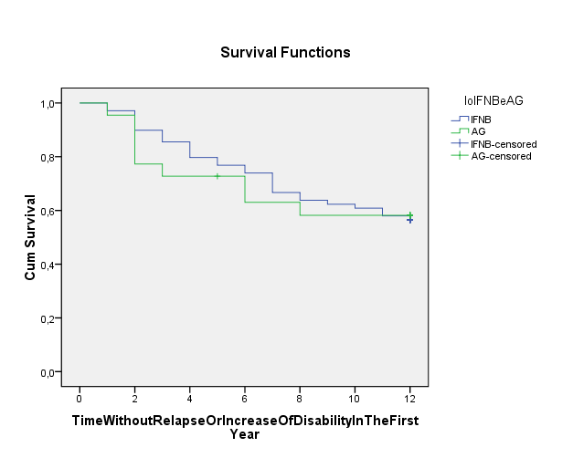

Kaplan-Meier curves showing, by treatment response arm, the the probability of avoiding relapse or progression of MS equal to at least 1 EDSS point in the first year after start use of immunomodulators

