A forecast of regional atmospheric electric discharges for Southeast Brazil: a case study

L.F. Mattosa,*, G. J. Senab, F.C.C. Borgesa

*aNational Institute for Space Research - INPE,*

*Center for Weather Forecast and Climate Studies - CPTEC*

*Rodovia Presidente Dutra, km 40, Cachoeira Paulista-SP, 12630000-Brasil*

*bJulio de Mesquita Filho University – FEG UNESP, Guaratingueta Campus-SP, 12516410-Brasil*

[1]a

### Abstract

### Incidences of atmospheric discharges are the cause of life and property losses, having a role in problems with power transmission lines, affecting their operation and potentially causing failures and interruptions. This work intends to examine the prognostic viability of the index of the Lightning Potential Index (LPI) and the value of the special overlay of Transmission Lines (buffer),which is a parameter for the development of the statistical analysis of atmospheric discharges in their premises and consequently for the estimation of failure risk. The processed data was used in the output of the ETA-20 and 5-km regional models from the CPTEC/INPE. The case chosen for the test occurred at 00:00 UTC on September 24th, 2010, when the atmospheric discharges registered by the sensors reached the South and Southeast regions in Brazil. The diagnostic method consisted in determining the values of variables directly derived from the equations presented. The calculations resulted in LPI and buffer values confronted with satellite GOES-E images and with the lightning registered and plotted. In analogy, prognostic test was made based on the initial condition of 12 UTC before, for a period of subsequent 12 hours, coinciding with the chosen event. The experiment resulted sufficiently satisfactory to affirm that it is possible to carry out short term forecasts (12 to 24 hours) of potential incidence of lightning over South America.

Keywords: Lightning Potential Index, Buffer, Meteorological Forecast

### Resumo: A previsão de descargas elétricas atmosféricas regionais para o Sudeste do Brasil: um estudo de caso

### As descargas atmosféricas causam perdas de vidas e de propriedades, gerando problemas em linhas de transmissão de energia, afetando seu funcionamento ocasionando falhas e interrupções. Este trabalho pretende examina a viabilidade do “Lightning Potential Index“ (LPI) e o valor da sobreposição especial de linhas de transmissão (buffer), que é um parâmetro para o desenvolvimento da análise estatística das descargas atmosféricas instalações e, consequentemente, para a estimativa do risco de falhas. Foi usado a saída do modelo regional ETA-20 com 5 km de resolução processado no CPTEC/INPE. O estudo de caso escolhido para o teste ocorreu às 00:00 UTC em 24 de setembro de 2010, quando as descargas atmosféricas registradas pelos sensores chegou às regiões Sul e Sudeste do Brasil. O método de diagnóstico consistiu em determinar os valores das variáveis ​​derivadas diretamente das equações apresentadas. Os cálculos resultaram no LPI e valores de buffer e confrontados com imagens do satélite GOES-E e com o relâmpago registrados e plotados. Na analogia, foi usado o teste prognóstico com base na condição inicial de 12 UTC, por um período de 12 horas, coincidindo com o evento escolhido. O experimento foi suficientemente satisfatório para afirmar que é possível realizar previsões de curto prazo (12 a 24 horas) de potencial de incidência de raios na América do Sul.

### Palavras-chave: Índice potencial de raios, buffer, previsão meteorológica.

**1. Introduction**

The occurrence of lightning causes loss of property and lives, and problems in electric power transmission lines, being a potential cause of outages. This study aims to examine the feasibility of using prognostic Lightning Potential Index (LPI) (Frisbie et al., 2009) to also predict the possibility of affecting transmission lines to reach them directly or on its surrounding (buffer) (Flach et al., 2010). In the case occurred on the date of 00:00 UTC September 24, 2010 to 20:00 UTC before, this is the time to the processed data of the regional models ETA-20 and ETA-5km of CPTEC-INPE to generate analysis of meteorological variables related with the lightning recorded by sensors from the Brazilian Atmospheric Electrical Discharge Detection Network (BrasilDAT) installed in the southern and southeastern Brazil. It also allows repeat the methodology for calculating the 12-hour forecast from 12:00 to 24:00 UTC.

The results show that it is possible to combine buffer (b) with and without topography (a) as a function of height from the center of negative charges (hn) and it is a function of LPI. The spatial and temporal distribution on South America is well detailed in two distinct areas: of clear sky and of disturbed sky. A virtual structure height (hst) value of 3 m which is the height of the electrode to global clear sky (Hopper et al., 1986) as representing the basic state. Some variations[2]atare due to the disturbance generated by the meteorological phenomenon diagnosed by LPI. It uses the function of geometry (r) (Zhou et al., 2009,2010) as a correction factor of b. The lightning phenomenon occurs only when there is disturbance in the basic state, by changing hn, hst and b.

**2. Method**

The regional models ETA-20 and ETA-5km of CPTEC-INPE provide all the necessary variables to calculate LPI, defined by the following equation (Frisbie et al., 2009):

**  (1)

where RH is the relative humidity at -10 C (%); CAPE is the most unstable convectively available potential energy in the range 0-3 km AGL (J/kg); PW is the precipitable water (mm); LI is the Lifted Index (K); T850 is the 850 hPa level Temperature (K); and ΘeΓ is the Equivalent Potential Temperature at 600 hPa Lapse Rate (K/m).

The minimum value of LPI is zero and the maximum is 20,000. Then to belong the range 0-20,000 divide by (absolute maximum value)/20,000.

The determination of the buffer is made by the following equation (Flach et al., 2010):

**  (2)

where b is the horizontal distance of discharge into the buffer limit to the structure (m); hn is the center height of the cloud of negative charges (m); and hst is the virtual height of he estructure.

To relate the LPI, buffer as low as for hst at 3 m was considered a result of the electrode effect, as the basic state for clear sky. This relationship is defined by bs from the equation:

** (3)

where bs is the squared buffer on troubled part of the atmosphere (m²); bbar is the buffer of the basic state with clear sky (m); fc is the correction factor when the line between clear sky and disturbed sky assumes values 200 m and 160 m for buffer and for buffer on independent part of the topography, respectively and for value zero of the a; r is the function of hemispherical geometry for the provided by the ETA-20 model topography a (m) and its particular case without topography is r0; and bl is the disturbance buffer around the buffer medium in the range 700-1,200 (m) (Flach et al., 2010).

The height of the center of negative charges, when disturbed by the LPI, was recalculated within the algorithm by the equation:

**  (4)

where c is the pseudo-adiabatic lapse rate –0.0065 (K/m); R is the universal constant of gases 287.04 (J/kg/K); g is the acceleration of gravity 9.801 (m/s²); the value 263.15 is of the temperature –10 C in K; and fLPI is the natural logarithmic function of LPI (Eq. (1)), calculated by the algorithm, also. Then, the hn of the Eq. (2) is rewrited as:

** (5)

where hnbar assumes the value 5,750 m and is the average height of the center of negative charges in the range 4,000-7,500 (Flach et al., 2010); fzht is the freezing level height (m); and the value 209.99 m is of the basic state buffer on the line between continent and ocean. Then, the bs of the Eq. (3) is rewrited as:

** (6)

then, for basic state and for topography zero (bs as been the square of 209.99), the hnl assumes the value 202.597 m and LPI consequently assumes the value 0.00509559 (Eq. (4)).

Furthermore, the LPI hypothetically is proportional to the peak of discharges (kA) observed in the BrasilDAT network as shown:

** (7)

where the values 2.236 and 0.01 are proportional to the maximum and the minimum of the peak of discharges observed for disturbed and clear skies, respectively.

**3. Results and conclusions**

The analysis showed the spatial distribution obtained by LPI and hn compatible with the channel Infrared Satellite GOES-E image (Fig. 1b) and with the plot made from the records of the sensors from BrazilDAT network (Fig. 1a). The same happens with the forecasts of 12 hours in advance. As b (Fig. 2a,b) depends on hn (Fig. 2c,d) and disruption of this depends on the LPI (Fig. 1c,d), is used therefore to diagnose and predict the different characteristics of the troposphere with respect to clear sky. For disturbed sky by the disruption of hn at the level of pressure where the temperature is 263.15 K, b is modified by topography. The threshold between the two states reaches 200 m and 160 m values for total b an partial b without topography. The experiment was very satisfactory to say that it is possible to predict 12 to 24 hs before hn, LPI and b. With the use of a virtual structure height of 3 m to represent the overall share of the lead (Hopper et al., 1986) for the basic state under a clear sky, it is understood that under troubled sky compounded by topography to satisfy the function of hemispheric geometry.

The model ETA-5km analysis of Peak of Discharges (kA) accounts its horizontal gradient (kA m) as proportional to LPI (Eq. (7)), and shows the value 0.000747025 in the median point defined by the observed Peak of Discharges (horizontal gradient equal to 0.000896651) on 0 hour 2 minutes 24th September 2010, at 25.7197S of Latitude and 49.4929W of Longitude. These values yield the ratio 1.2003, thus the methodology used in this study is reliable.

FIGURE CAPTIONS

(a) (b) (c) (d)

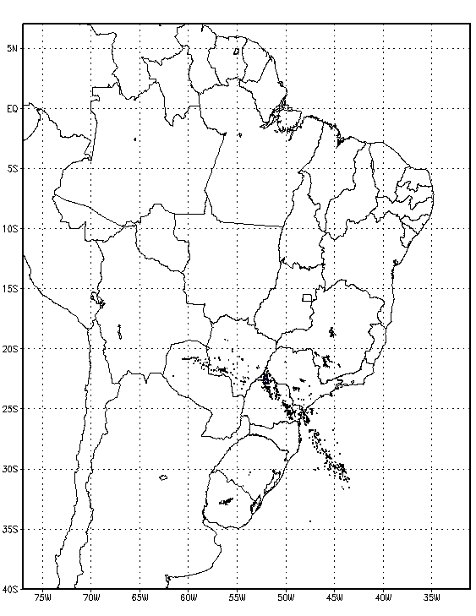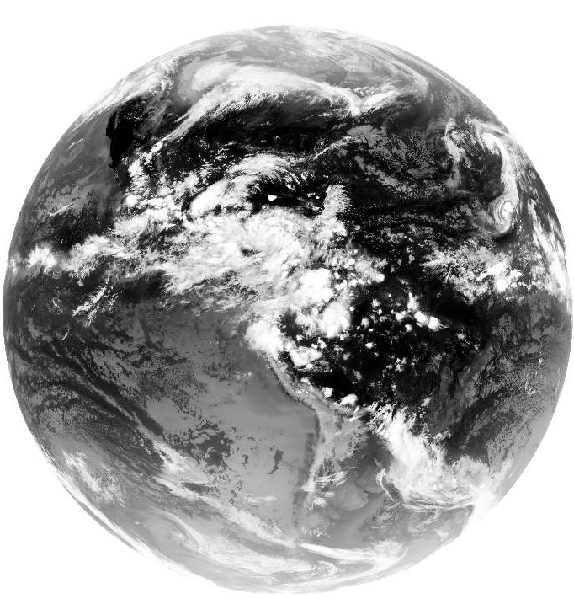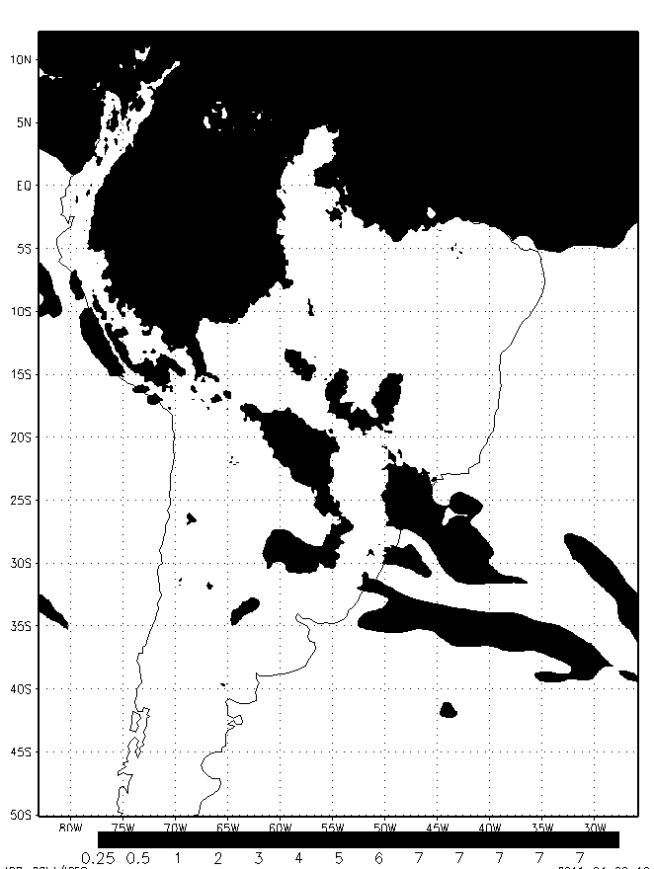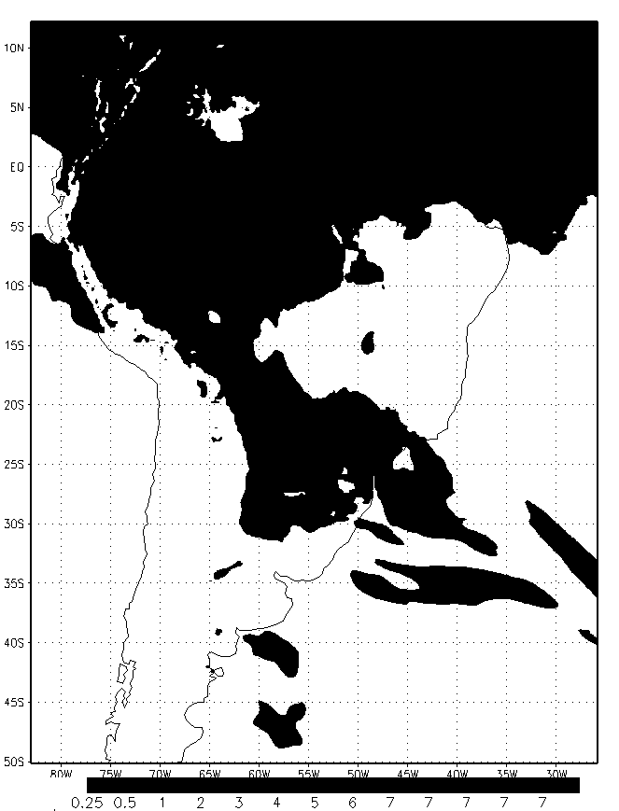

**Figure 1.** On 00:00 UTC 24Sep2010: a) lightning by sensors; and b) cloudiness by infrared channel GOES-E; and normalized for the range 0-7 Lightning Potential Index: c) analysis; and d) 12-hr forecasted.

(a) (b)

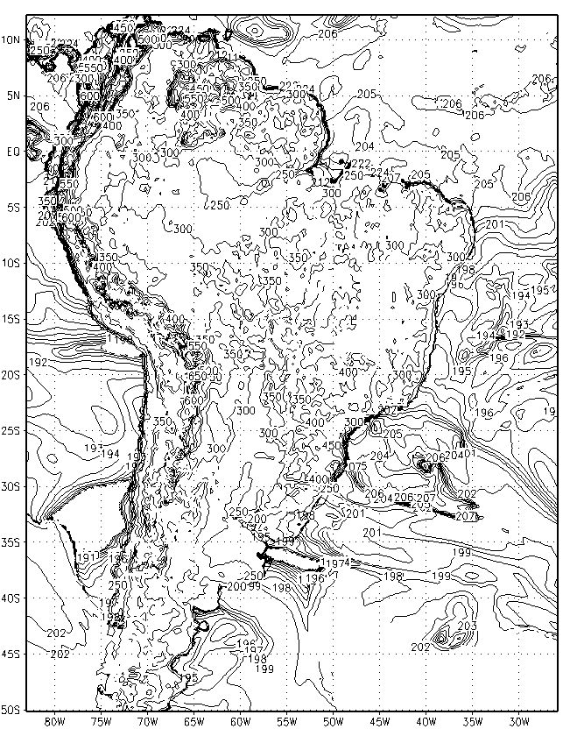 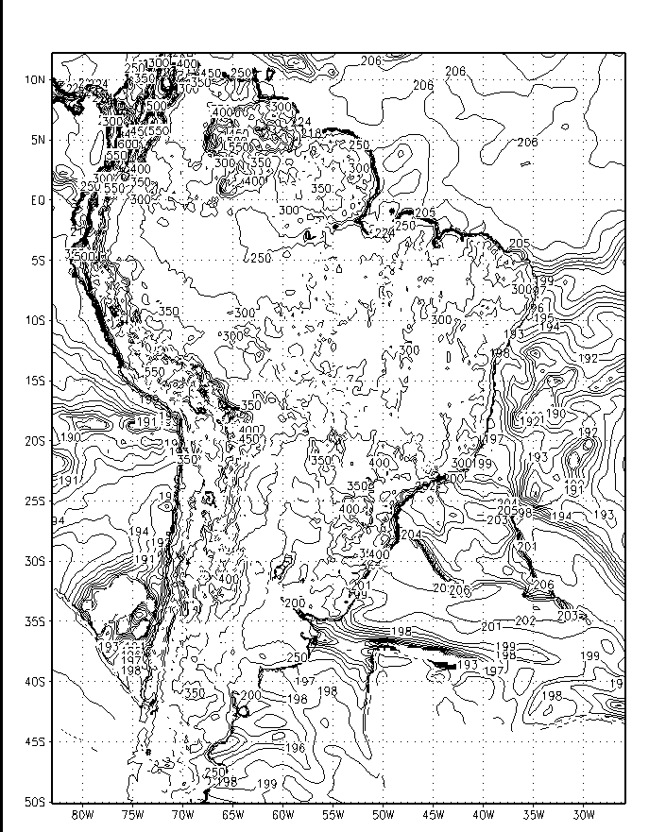 (c) (d)

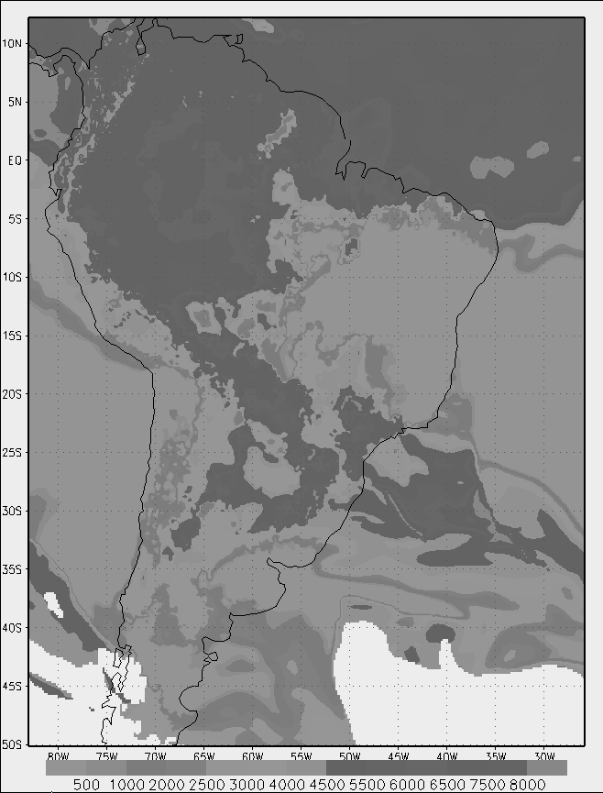 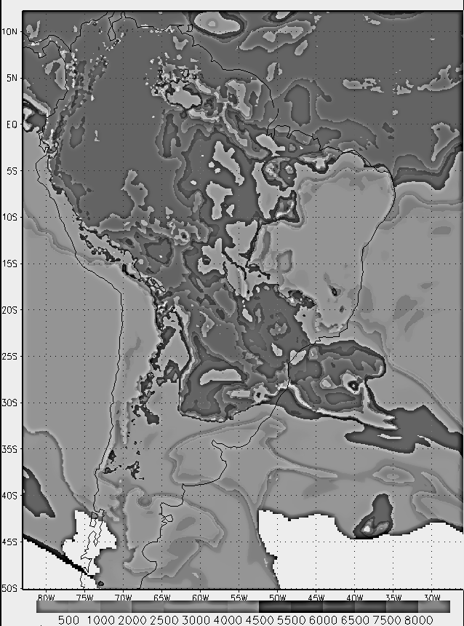

**Figure 2.** On 00:00 UTC 24Sep2010: Buffer (m): a) analysis; and b) 12-hr forecasted; contours: clear sky: 186-199 green over ocean, 200-450 black over continent; and disturbed sky: 200-224 blue over ocean, >224 cyan over continent; and height of the center of negative charges (m): c) analysis; and d) 12-hr forecasted.

**References**

Flach, R.A., Alvim, E.L., Jusevicius, M., 2010. Estimative of the negative charge height of the thundestorms. XVI CBMET Annals (in portuguese), Brazil.

Frisbie, P.R., Colton, J.D., Pringle, J.R., Daniels, J.A., Ramey Jr., J.D., Meyers, M.P., 2009. P1.5 Lightning prediction by WFO Grand Junction using model data and graphical forecast editor smart tools. Fourth Conference on the Meteorological Applications of Lightning Data, AMS Home Page.

Hopper, W.A., Anderson, R.V., Willet, J.C., 1986. Atmospheric electricity in the planetary boundary layer. Section on The Earth’s Electrical Environment. National Academic Press. C.11, pp. 149-165.

Zhou, H., Theethayi, G., Deindorfer, G., Thottappillil, R., Rakov, V., 2009. A new approach to estimation of effective height of towers on mountain tops for lightning incidence studies: sensivity analysis. X International Symposium on Lightning Protection.

Zhou, H., Theethayi, G., Deindorfer, G., Thottappillil, R., Rakov, V., 2010. On estimation of the effective height of towers on mountain tops in lightning incidences studies. Journal of Electrostatics 121, 415-418.

1. * Corresponding author. National Institute for Space Research - INPE, Center for Weather Forecast and Climate

   Studies - CPTEC, Rodovia Presidente Dutra, km 40, 12630-000 Cachoeira Paulista/SP, Brazil. Phone: + 55 – 12 –

   31868468; fax: + 55 – 12 - 31868515. *E-mail addresses:*[luiz.mattos@cptec.inpe.br](mailto:luiz.mattos@cptec.inpe.br) (L.F. Mattos), [gsenaunesp@gmail.com](mailto:gsenaunesp@gmail.com) (G.J. Sena), [fabio.borges@cptec.inpe.br](mailto:fabio.borges@cptec.inpe.br) (F.C.C. Borges).

  
2.